**Esercizio L9 di laboratorio:**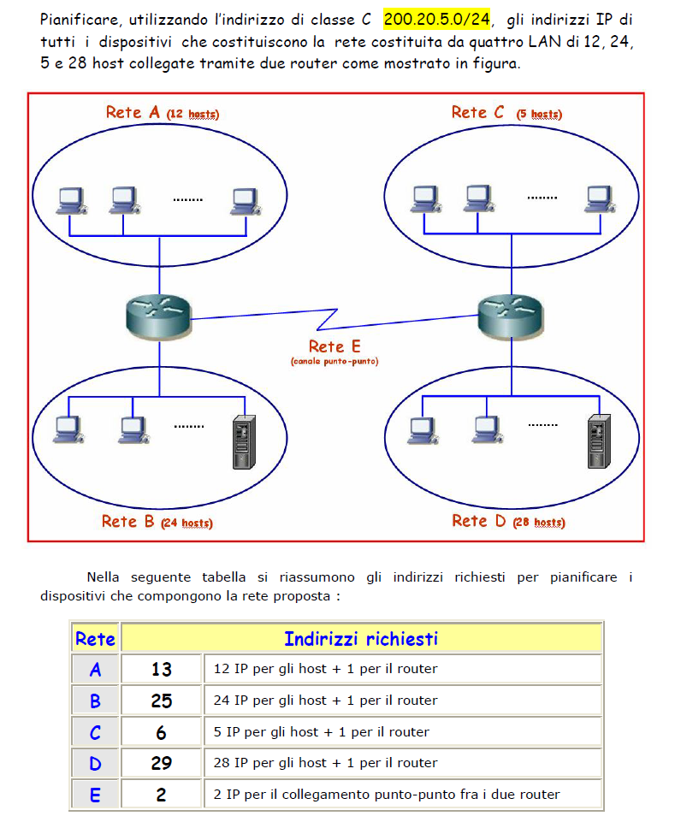

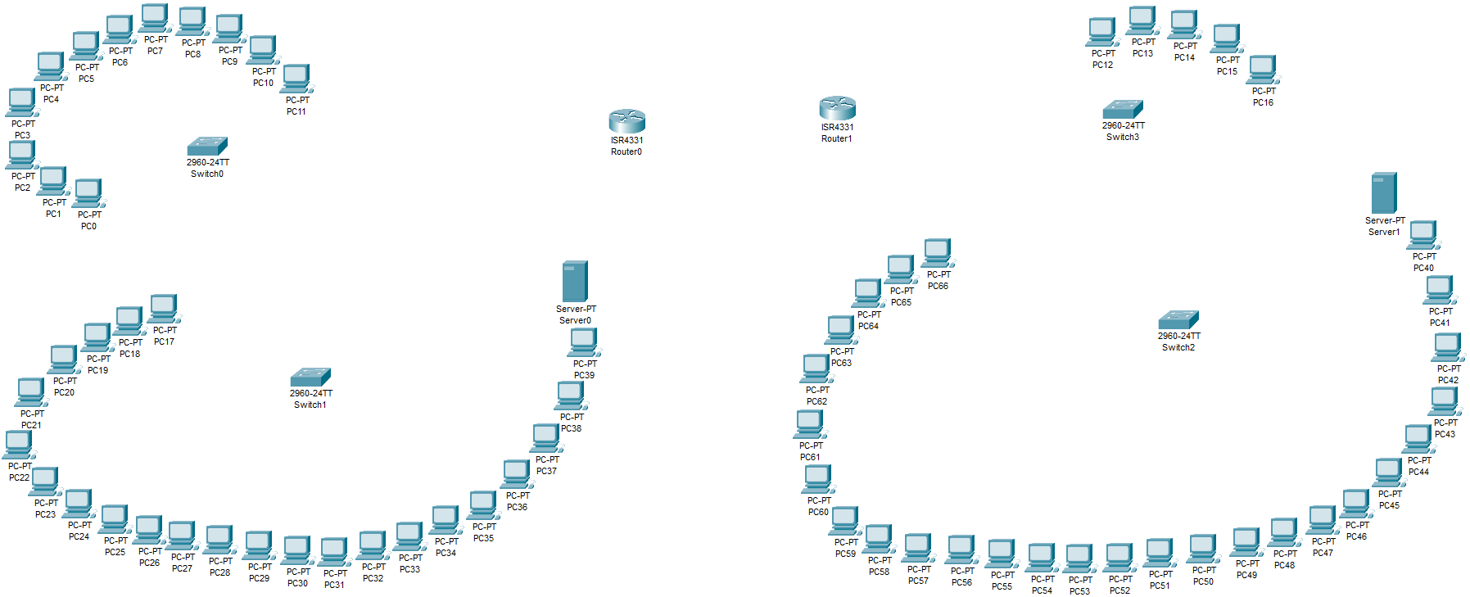**Struttura della rete:**

(Risultato iniziale)

**Componenti della Rete:**

1. **Rete A (12 host):**

* Dispositivi:
* **da PC-PT** **PC0** a **PC-PT** **PC11** (totale 12 PC)
* **Switch 2960-24TT (Switch0)**

1. **Rete B (24 host):**

* Dispositivi:
* **da PC-PT** **PC17** a **PC-PT PC38** (totale 23 PC)
* **Switch 2960-24TT (Switch1)**
* **Server-PT (Server0)**

1. **Rete C (5 host):**

* Dispositivi:
* da **PC-PT** **PC12** a **PC-PT** **PC16** (totale 5 PC)
* **Switch 2960-24TT (Switch3)**

1. **Rete D (28 host):**

* Dispositivi:
* da **PC-PT** **PC39** a **PC65** (totale 27 PC)
* **Switch 2960-24TT (Switch2)**
* **Server-PT (Server1)**

1. **Rete E (Collegamento punto-punto tra router):**

* **Dispositivi:**
* **Router0 e Router1** (collegamento punto-punto tra i due)

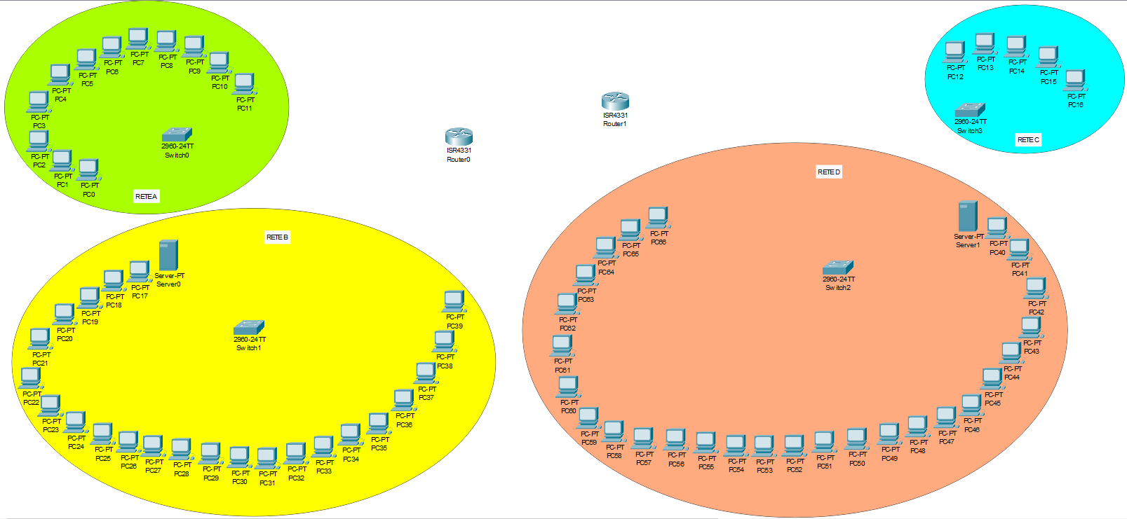**Totale = 12 (A) + 24 (B) + 5 (C) + 28 (D) + 2 (E) = 71 dispositivi**

(Risultato finale)

**Collegamenti dei Dispositivi nella Rete:**

**RETE A:**

* Collegare i PC (PC-PT PC0, PC-PT PC1, PC-PT PC2, PC-PT PC3, PC-PT PC4, PC-PT PC5, PC-PT PC6, PC-PT PC7, PC-PT PC8, PC-PT PC9, PC-PT PC10 e PC-PT PC11) allo switch 2960-24TT (Switch0) utilizzando le porte FastEthernet0/1, FastEthernet0/2, FastEthernet0/3, FastEthernet0/4, FastEthernet0/5, FastEthernet0/6, FastEthernet0/7, FastEthernet0/8, FastEthernet0/9, FastEthernet0/10, FastEthernet0/11 e FastEthernet0/12 dello switch e le porte FastEthernet0 dei PC con cavi copper straight-through.

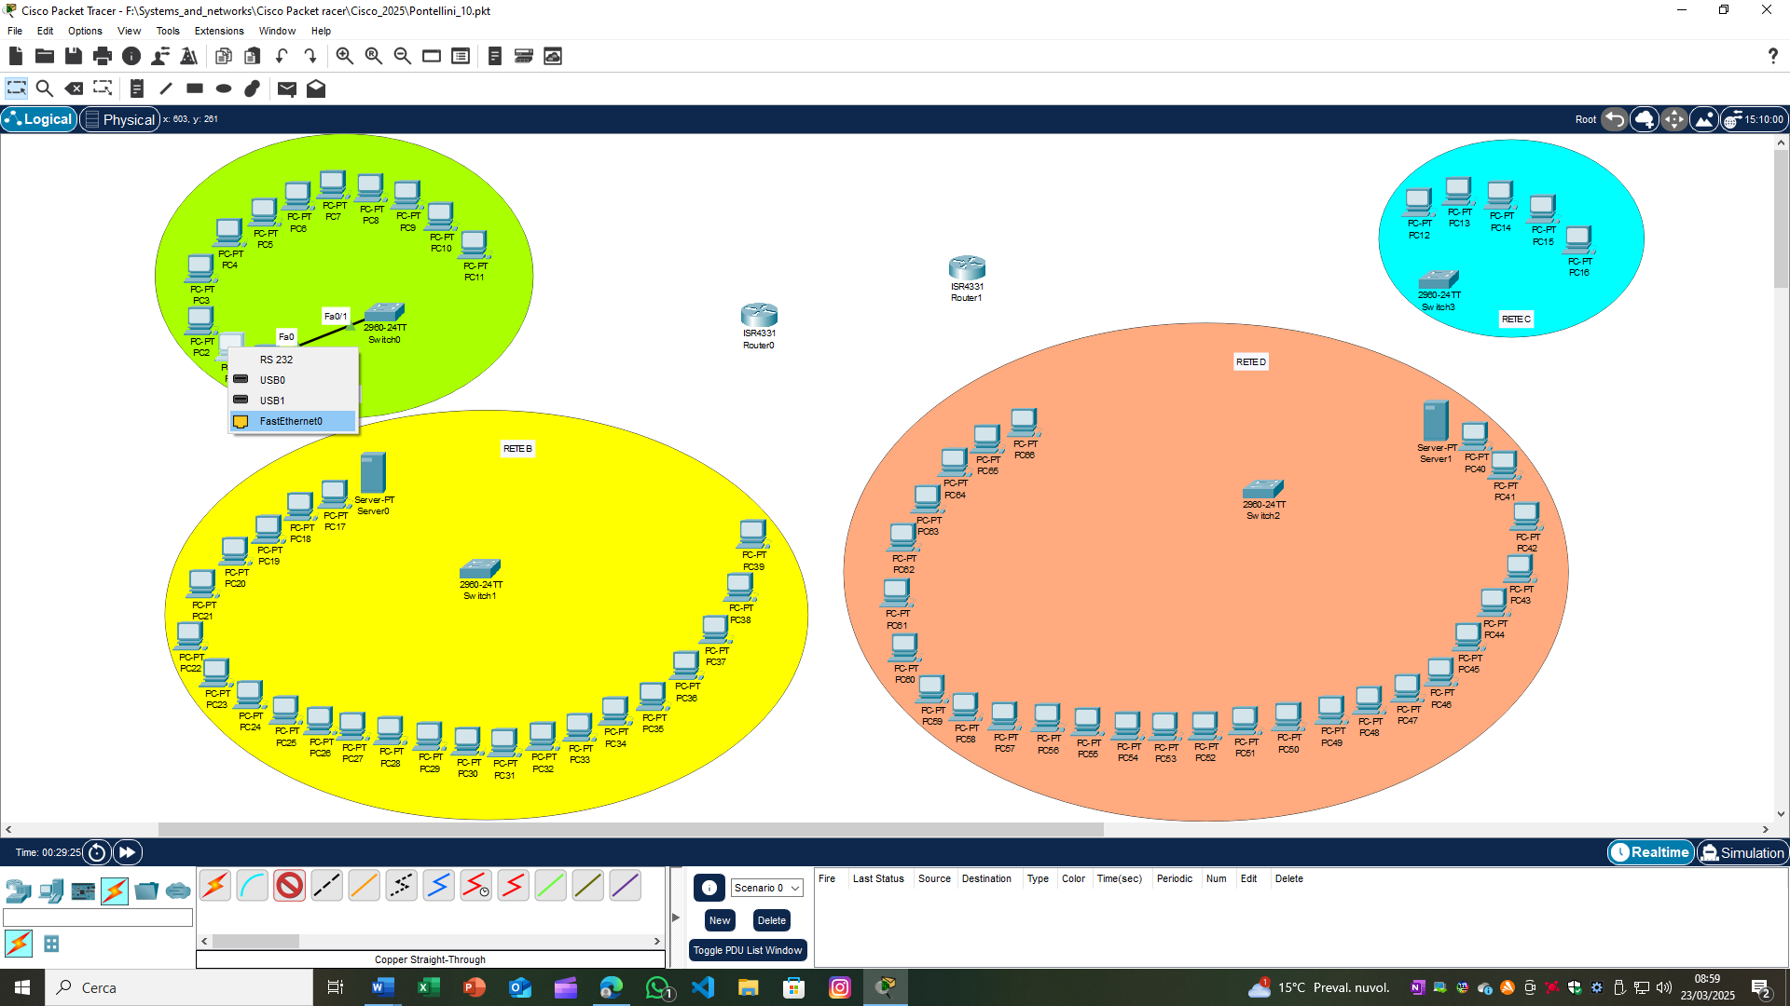

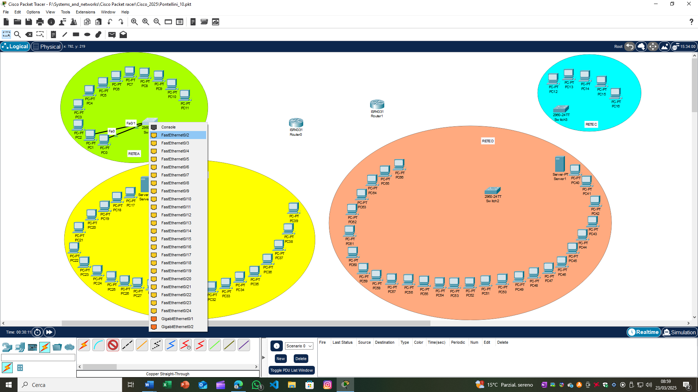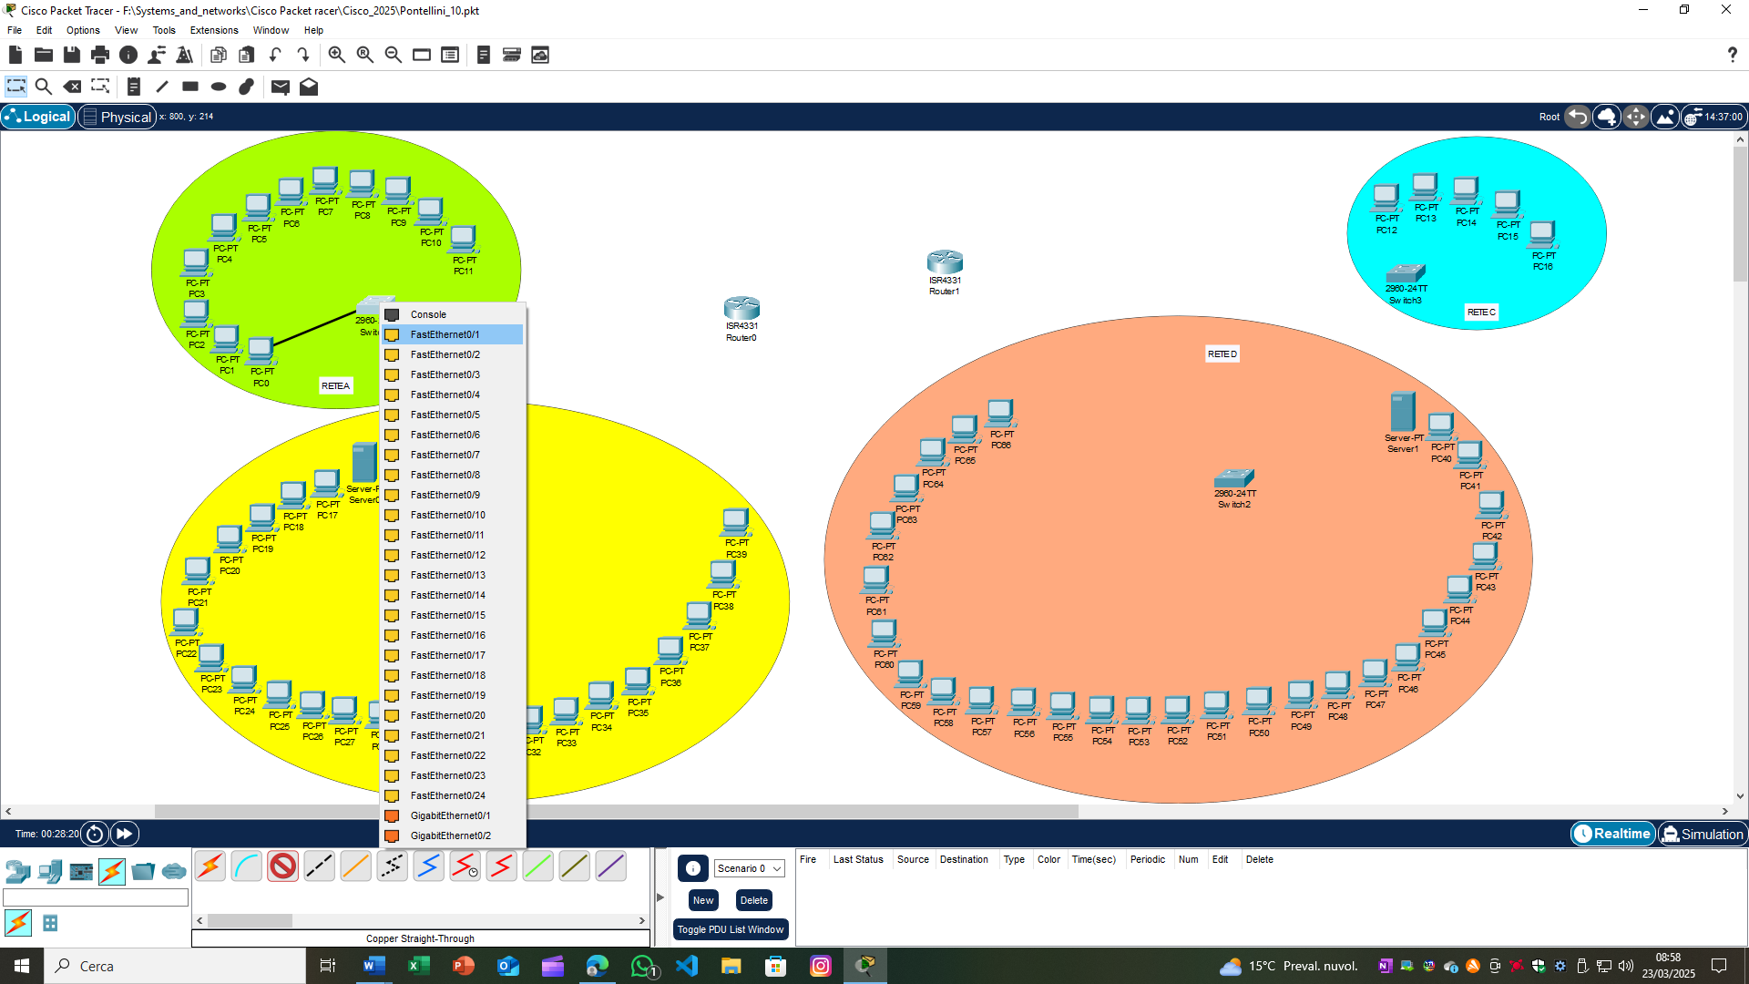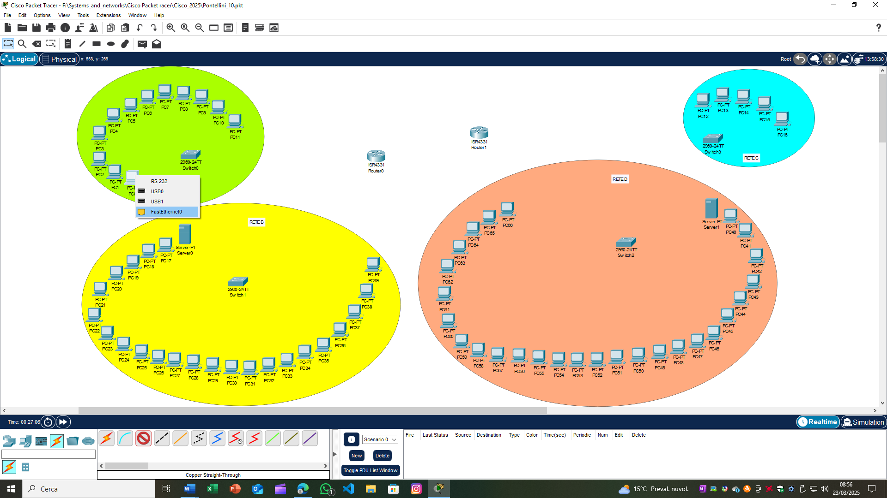

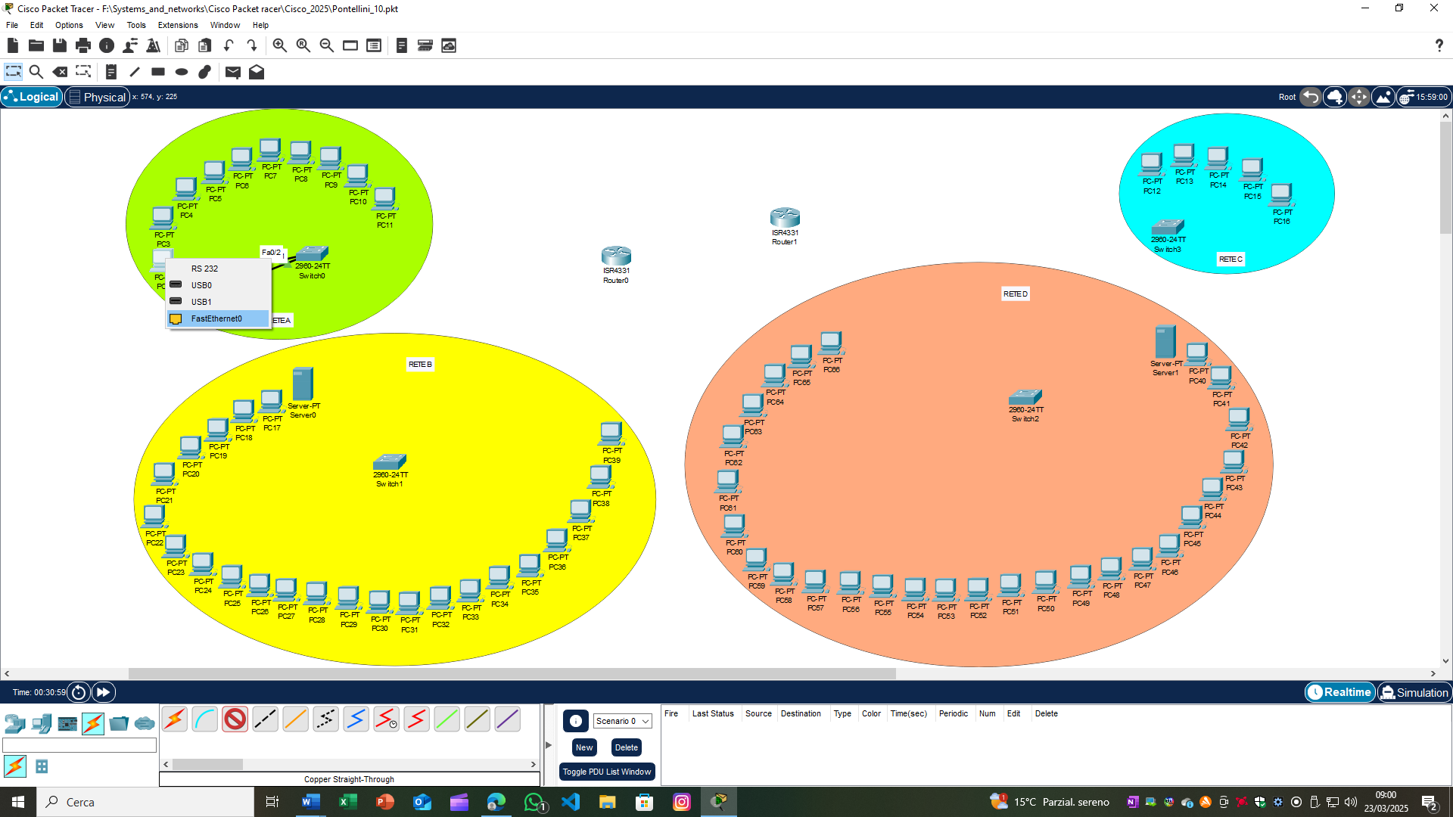

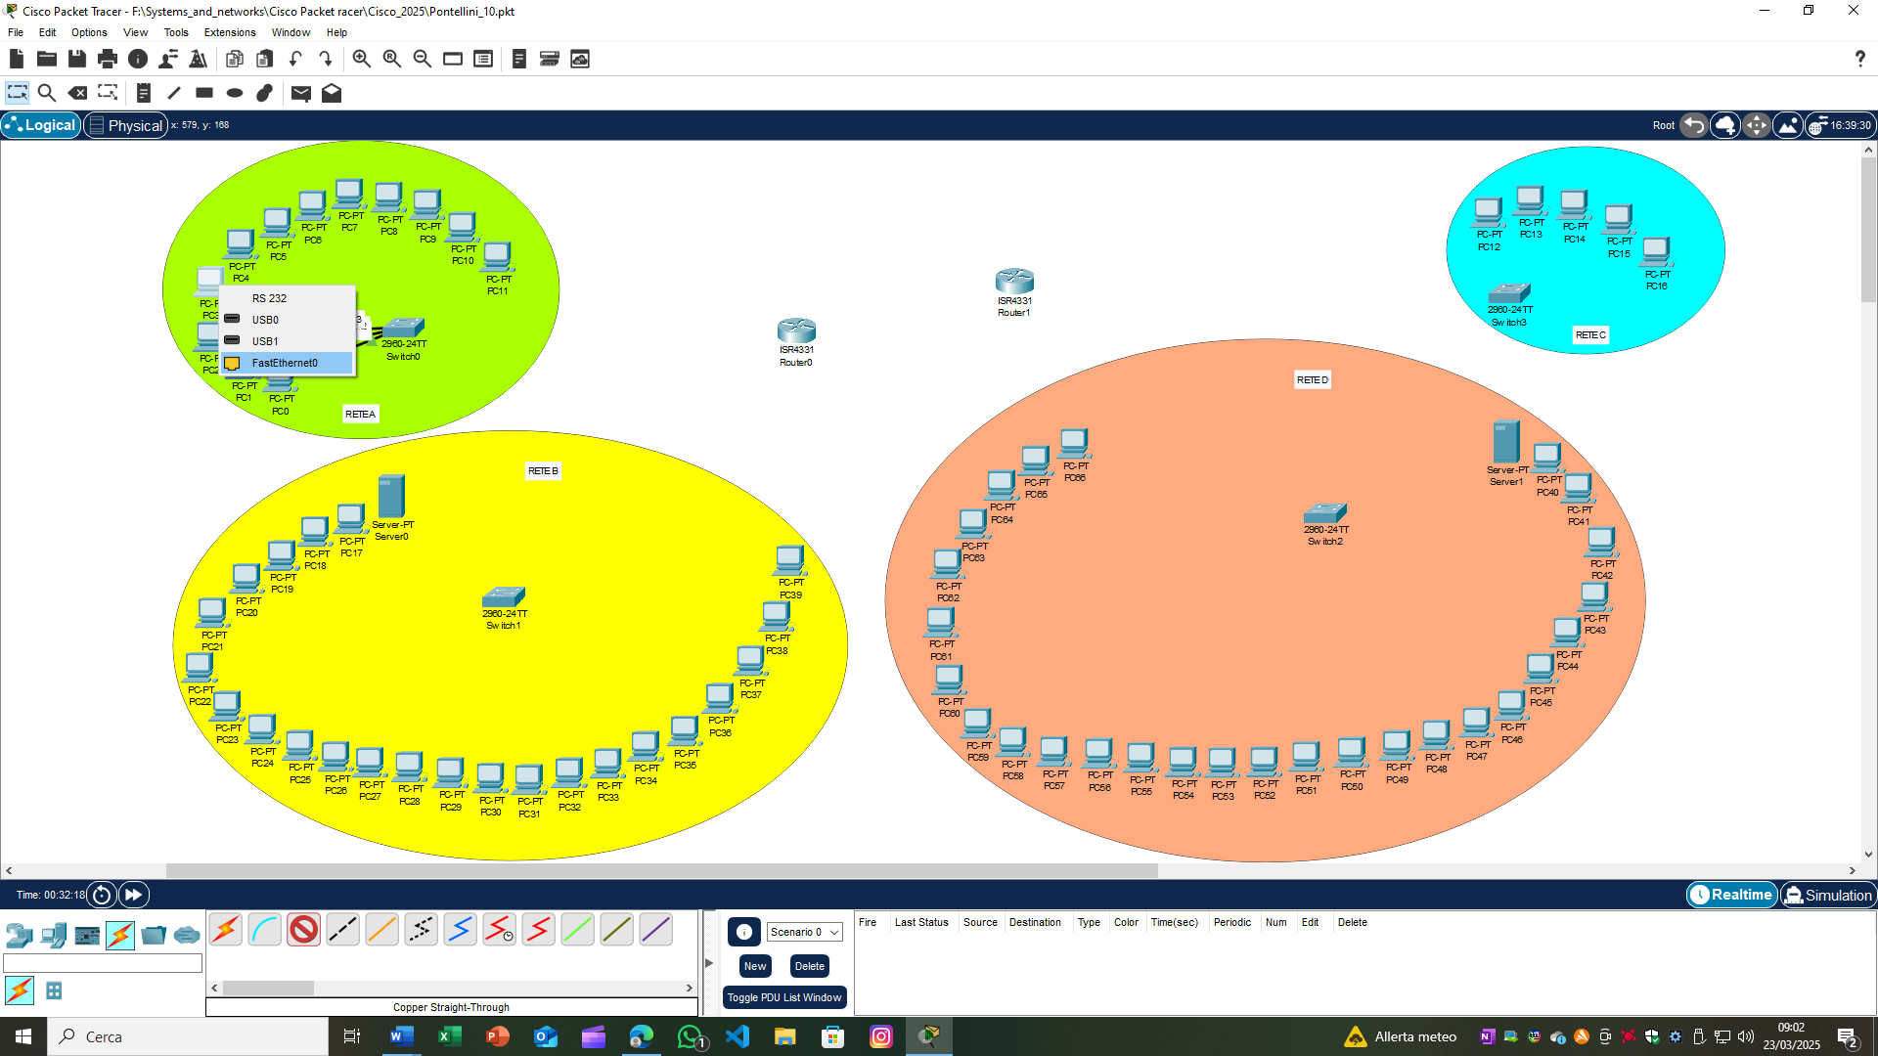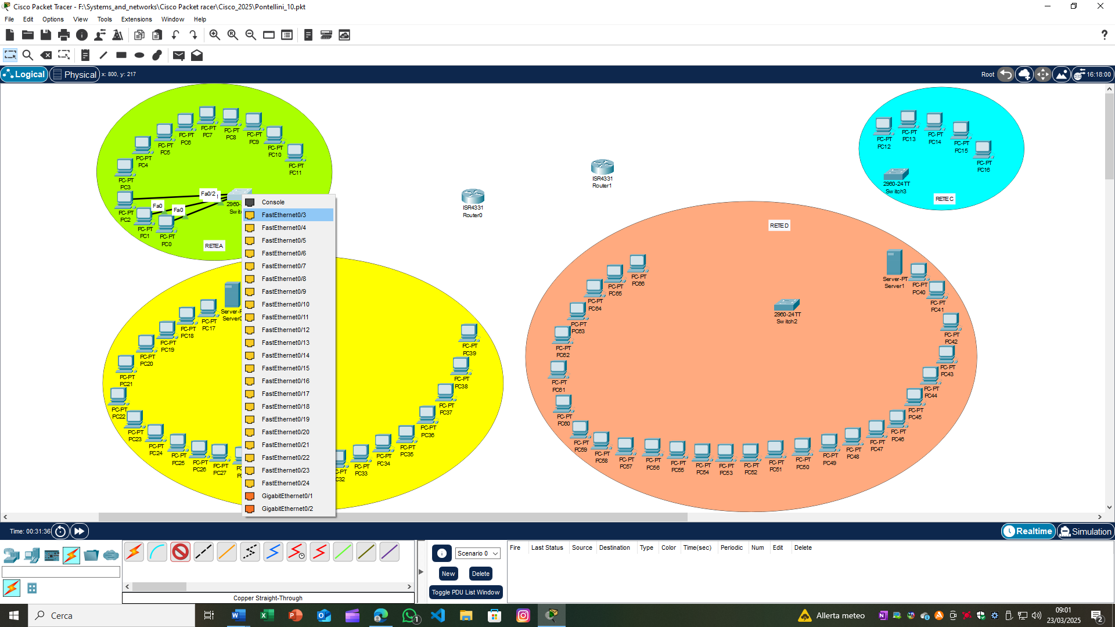

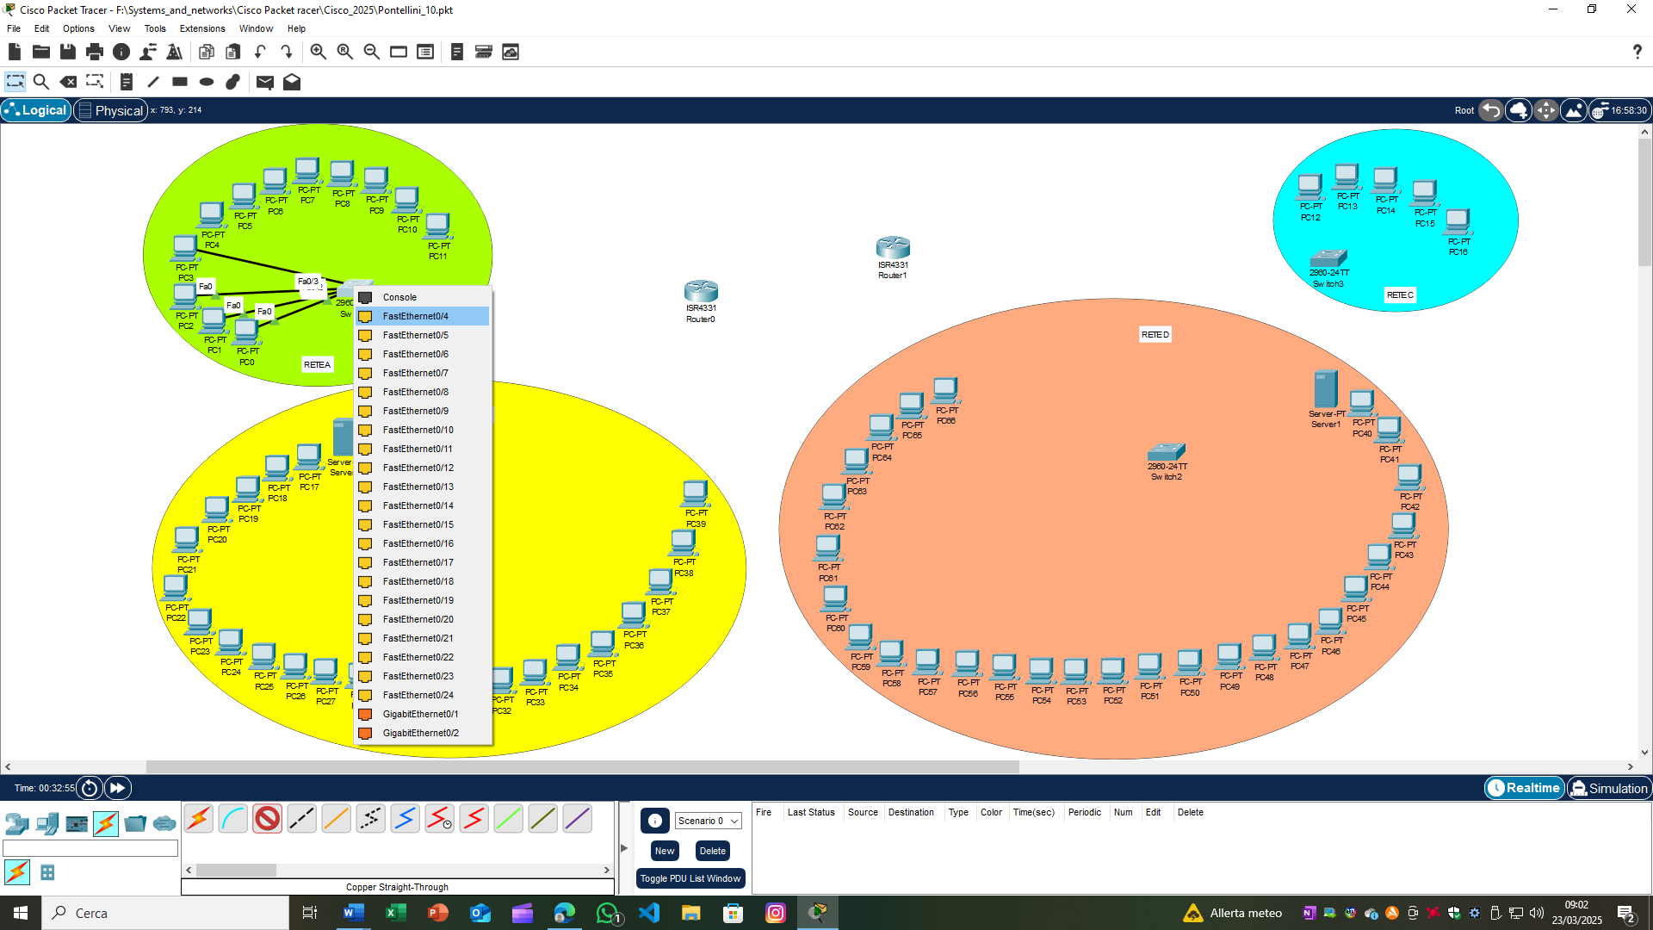

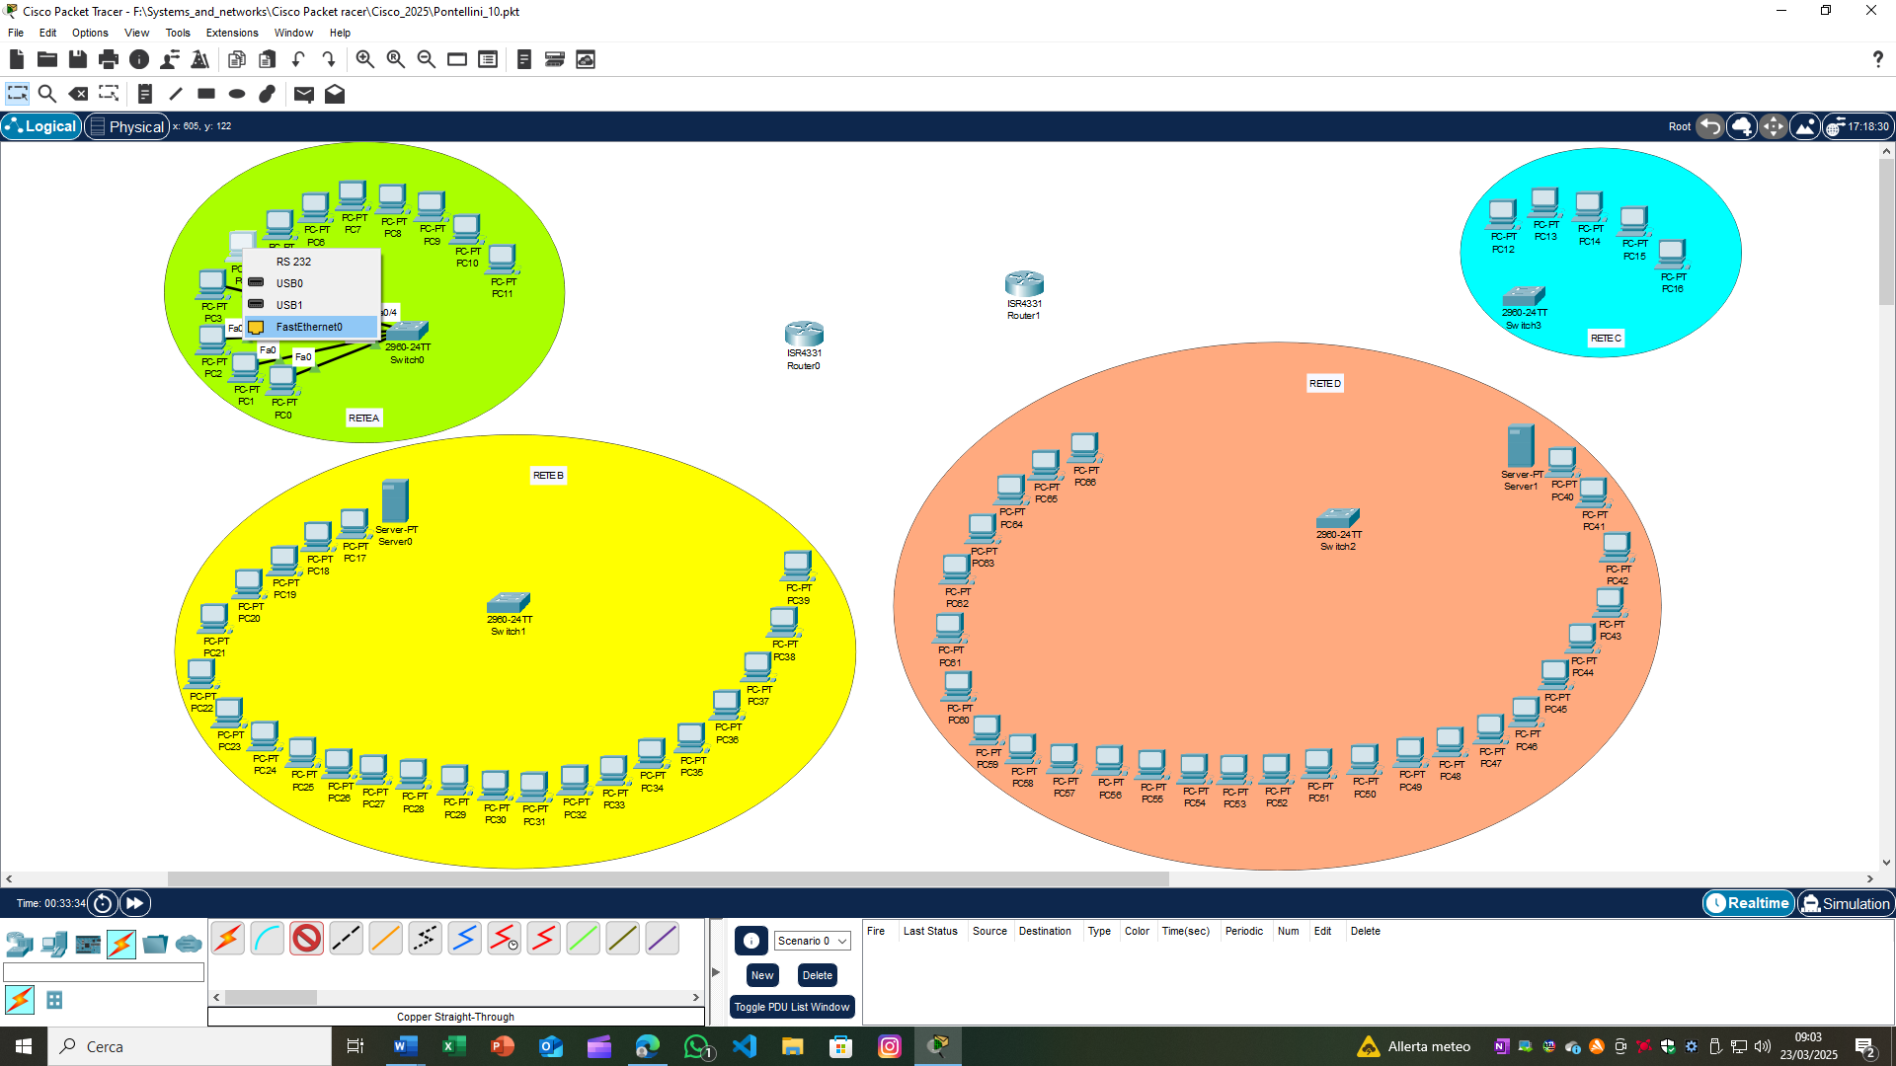

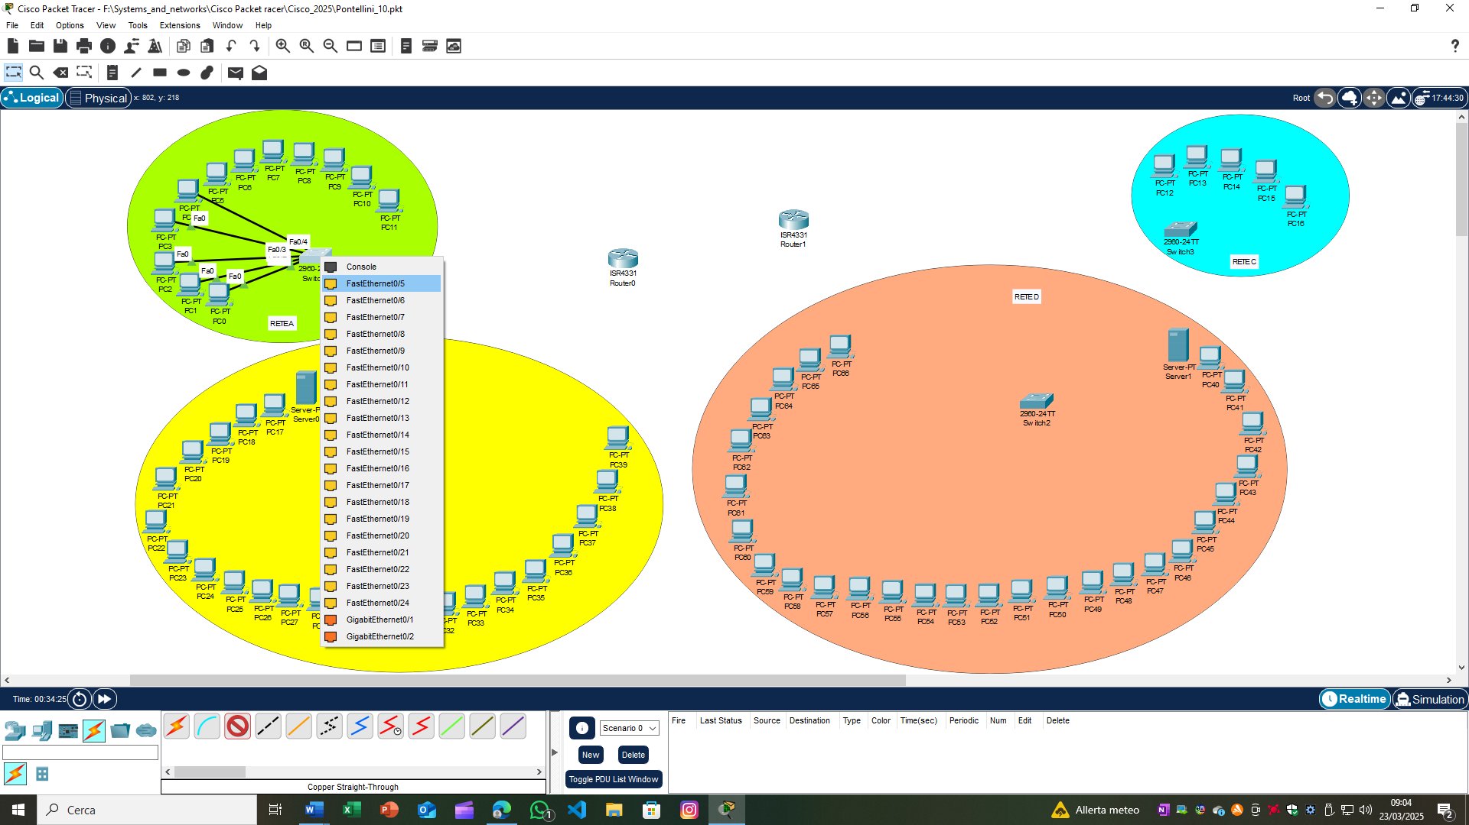

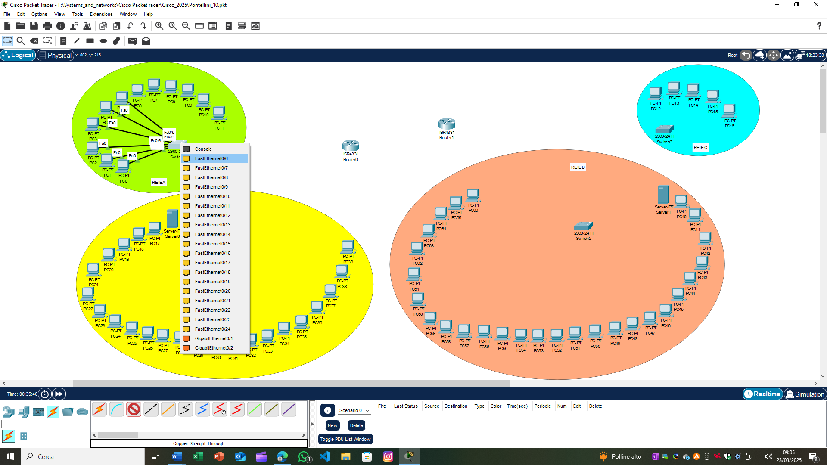

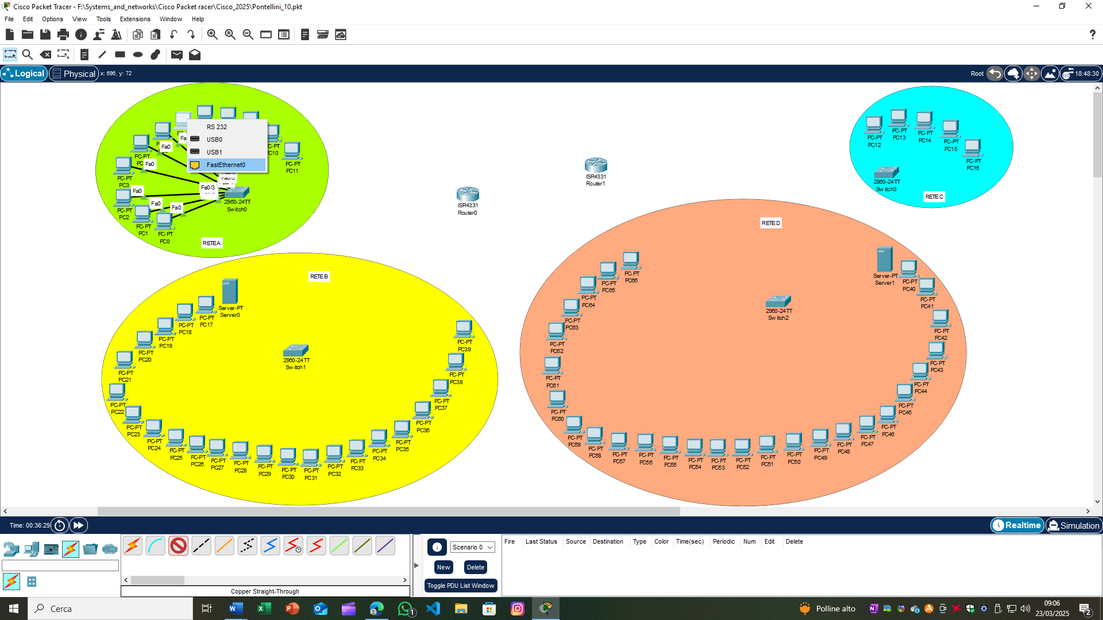

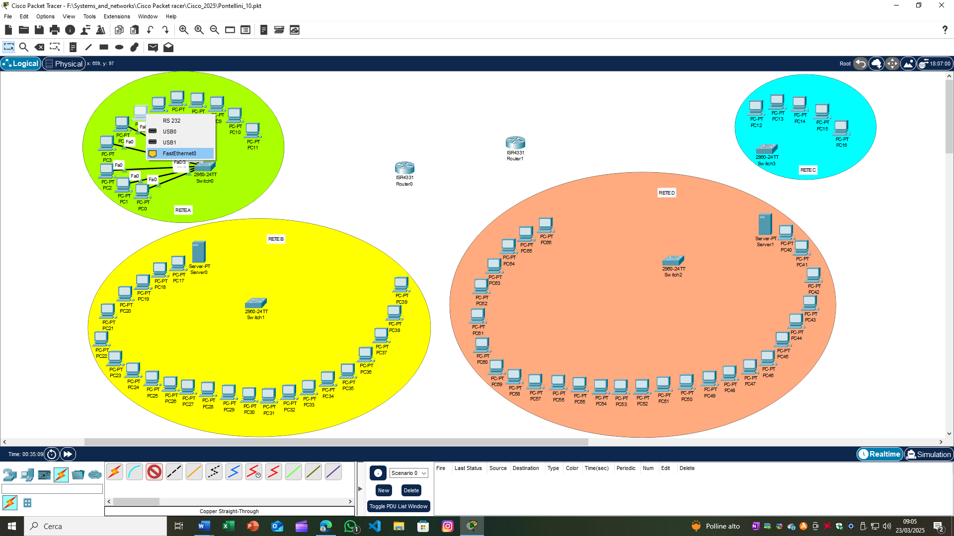

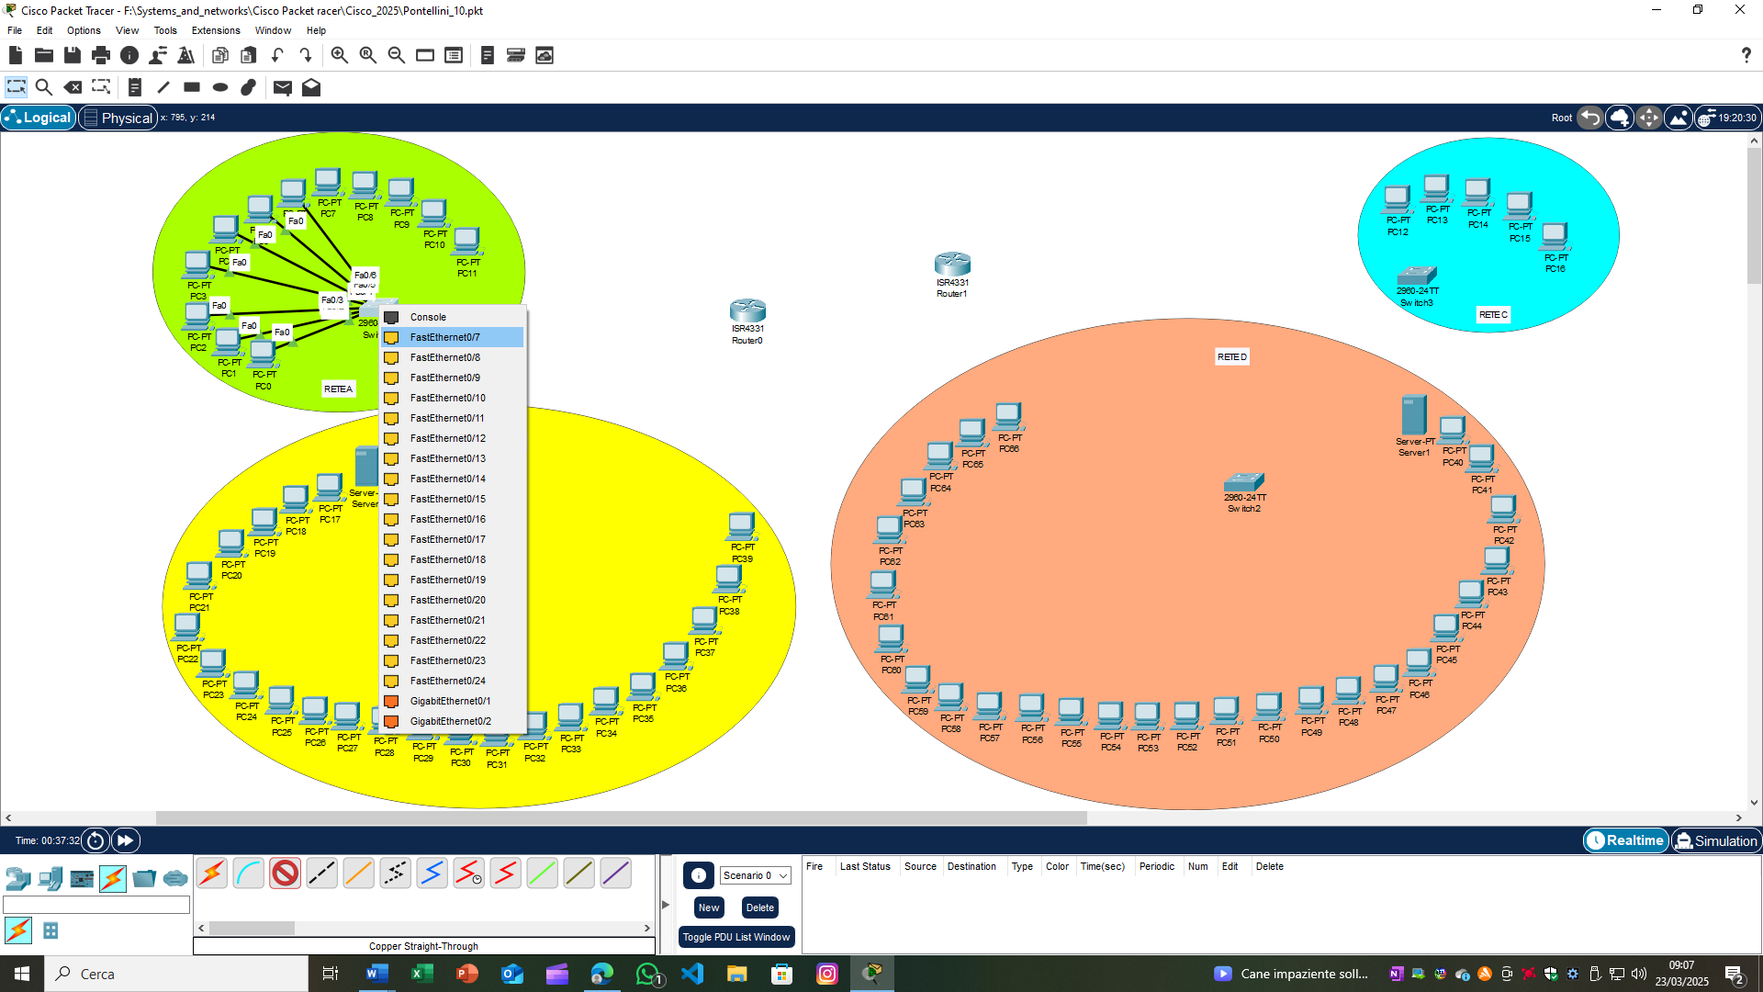

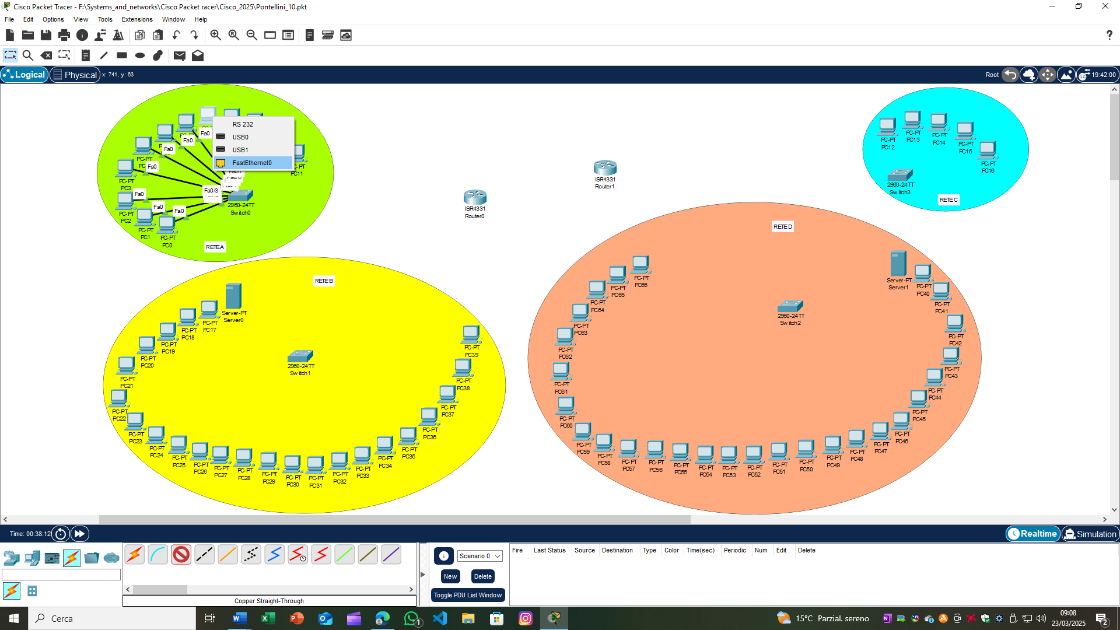

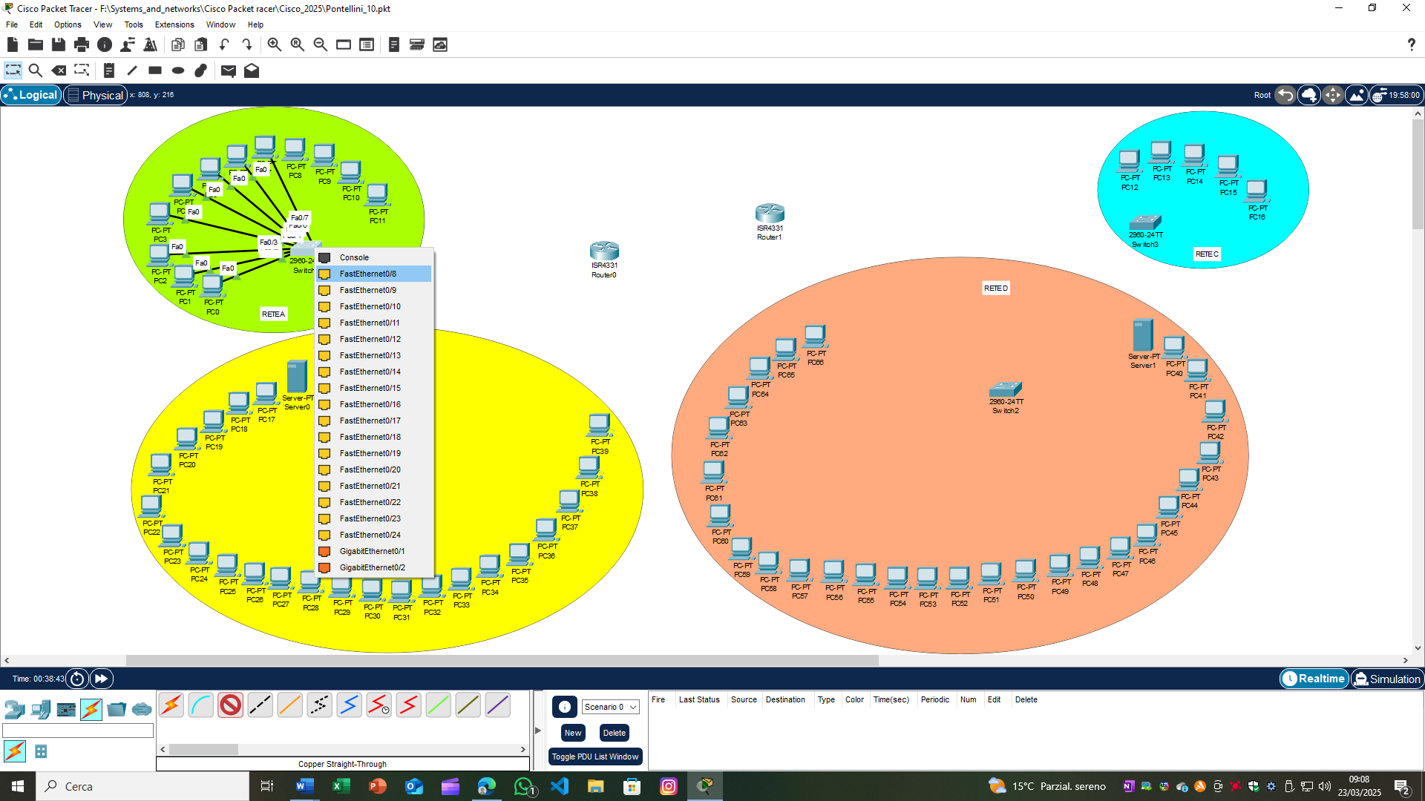

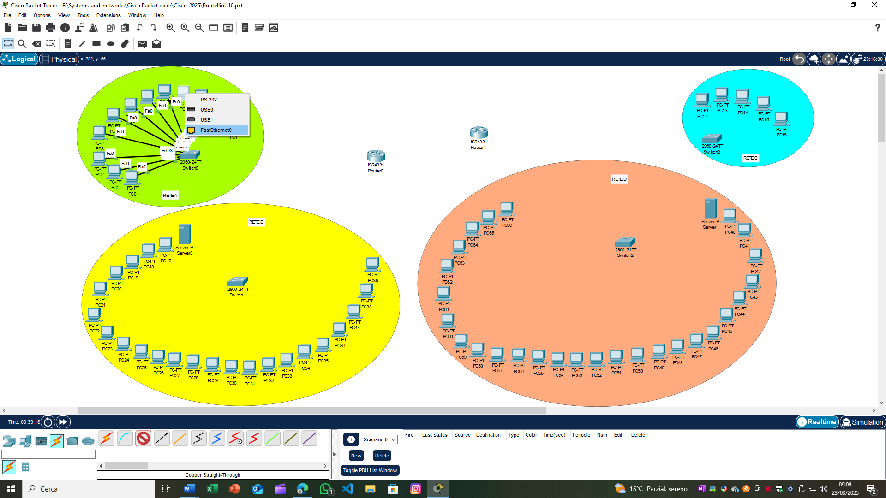

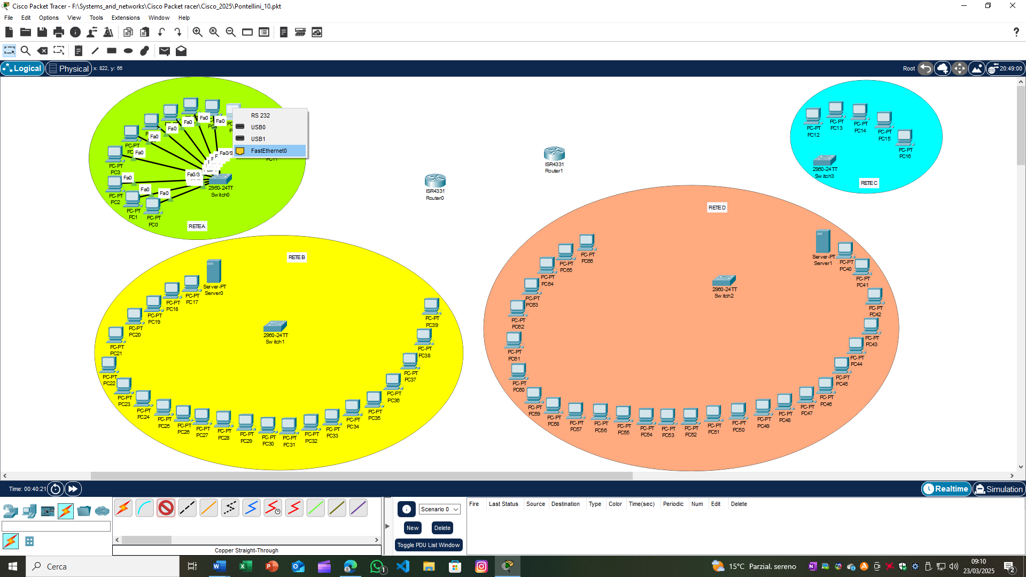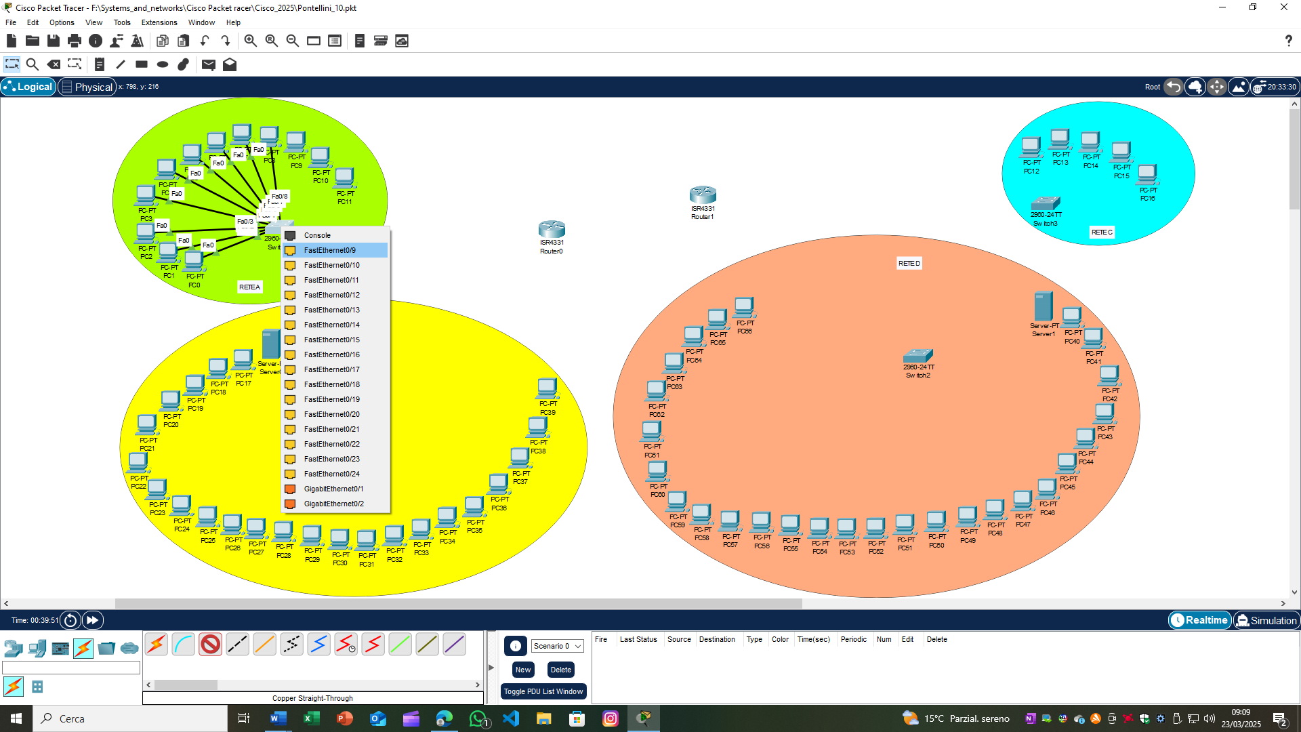

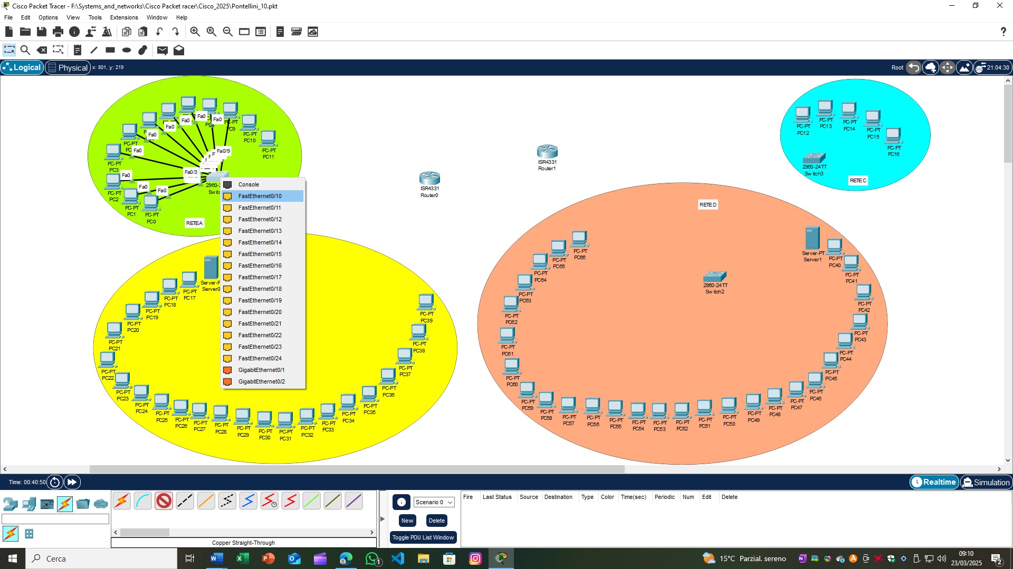

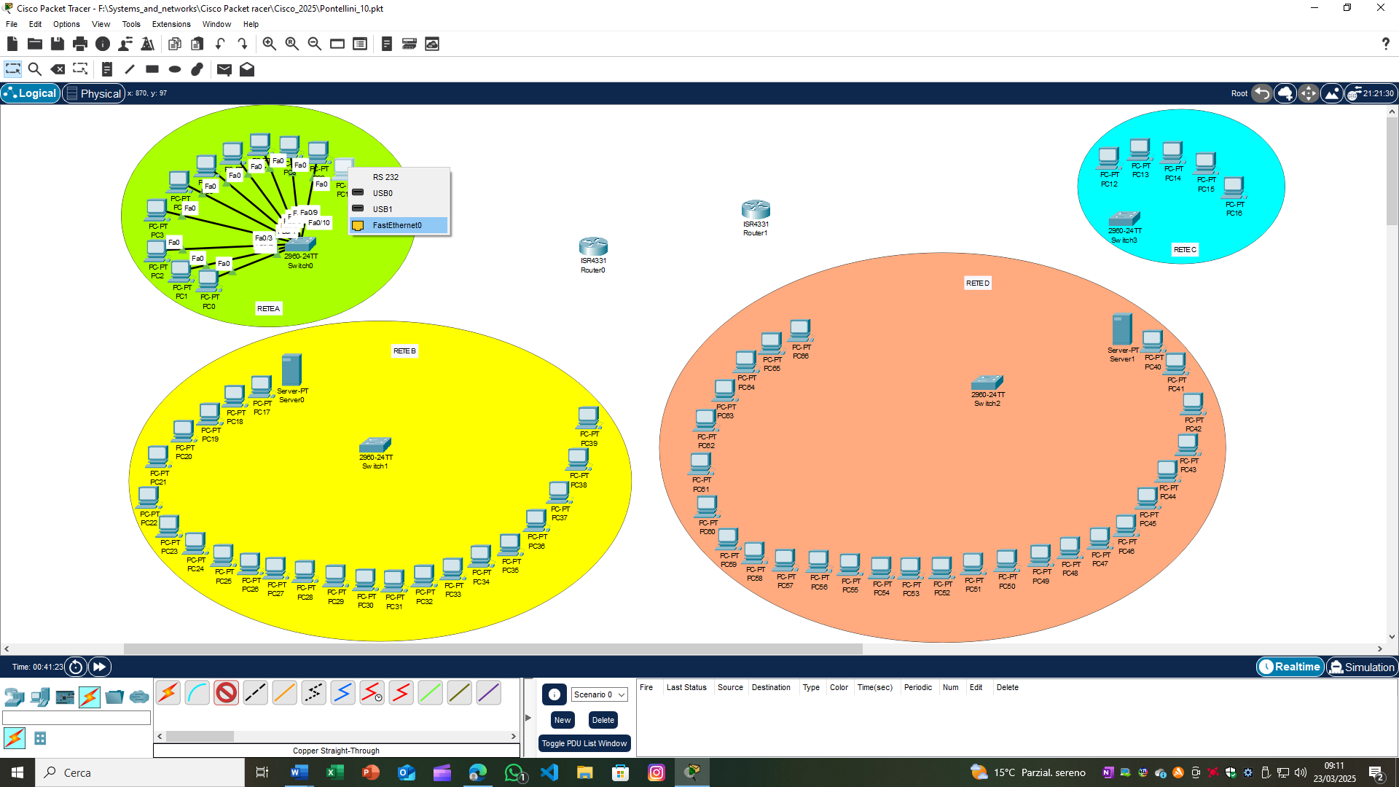

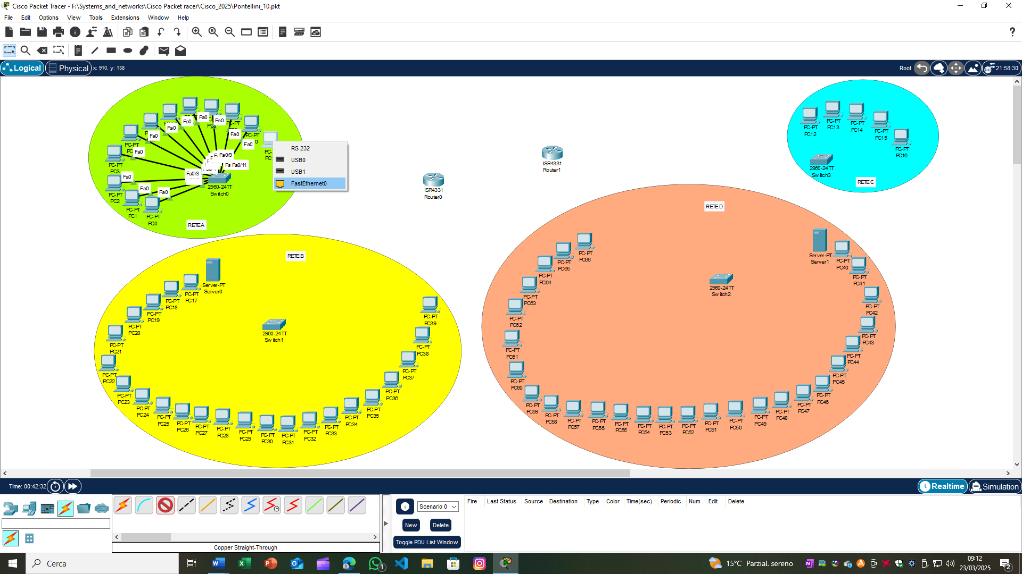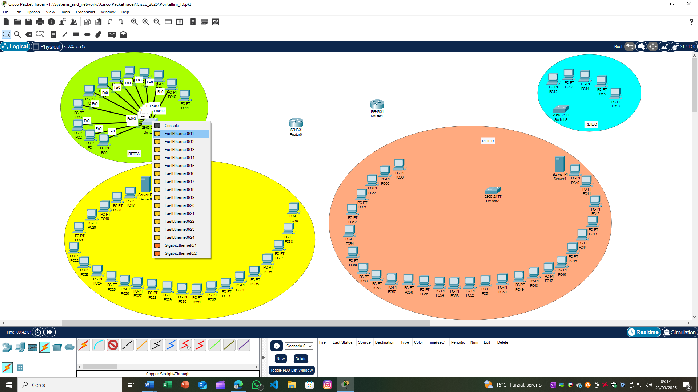

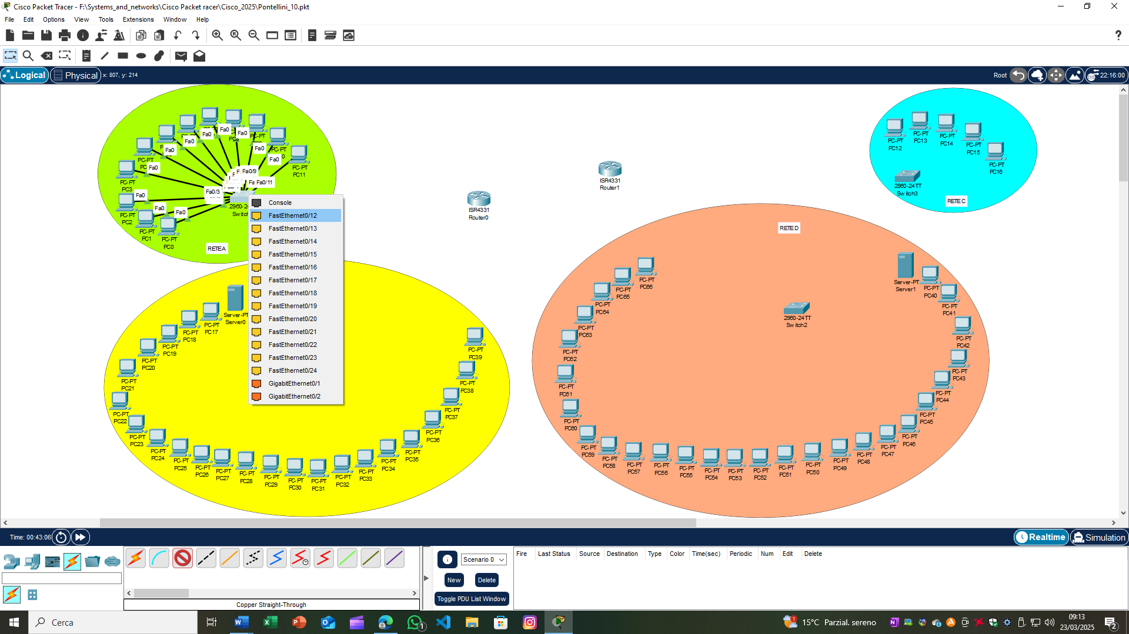

**RETE B:**

* Collegare i PC (PC-PT PC17, PC-PT PC18, PC-PT PC19, PC-PT PC20, PC-PT PC21, PC-PT PC22, PC-PT PC23, PC-PT PC24, PC-PT PC25, PC-PT PC26, PC-PT PC27, PC-PT PC28, PC-PT PC29, PC-PT PC30, PC-PT PC31, PC-PT PC32, PC-PT PC33, PC-PT PC34, PC-PT PC35, PC-PT PC36, PC-PT PC37, PC-PT PC38 e PC-PT PC39) e il Server-PT (Server0) allo switch 2960-24TT (Switch1) utilizzando le porte FastEthernet0/1, FastEthernet0/2, FastEthernet0/3, FastEthernet0/4, FastEthernet0/5, FastEthernet0/6, FastEthernet0/7, FastEthernet0/8, FastEthernet0/9, FastEthernet0/10, FastEthernet0/11, FastEthernet0/12, FastEthernet0/13, FastEthernet0/14, FastEthernet0/15, FastEthernet0/16, FastEthernet0/17, FastEthernet0/18, FastEthernet0/19, FastEthernet0/20, FastEthernet0/21, FastEthernet0/22, FastEthernet0/23 e FastEthernet0/24 dello switch e le porte FastEthernet0 dei PC e del Server0 con cavi copper straight-through.

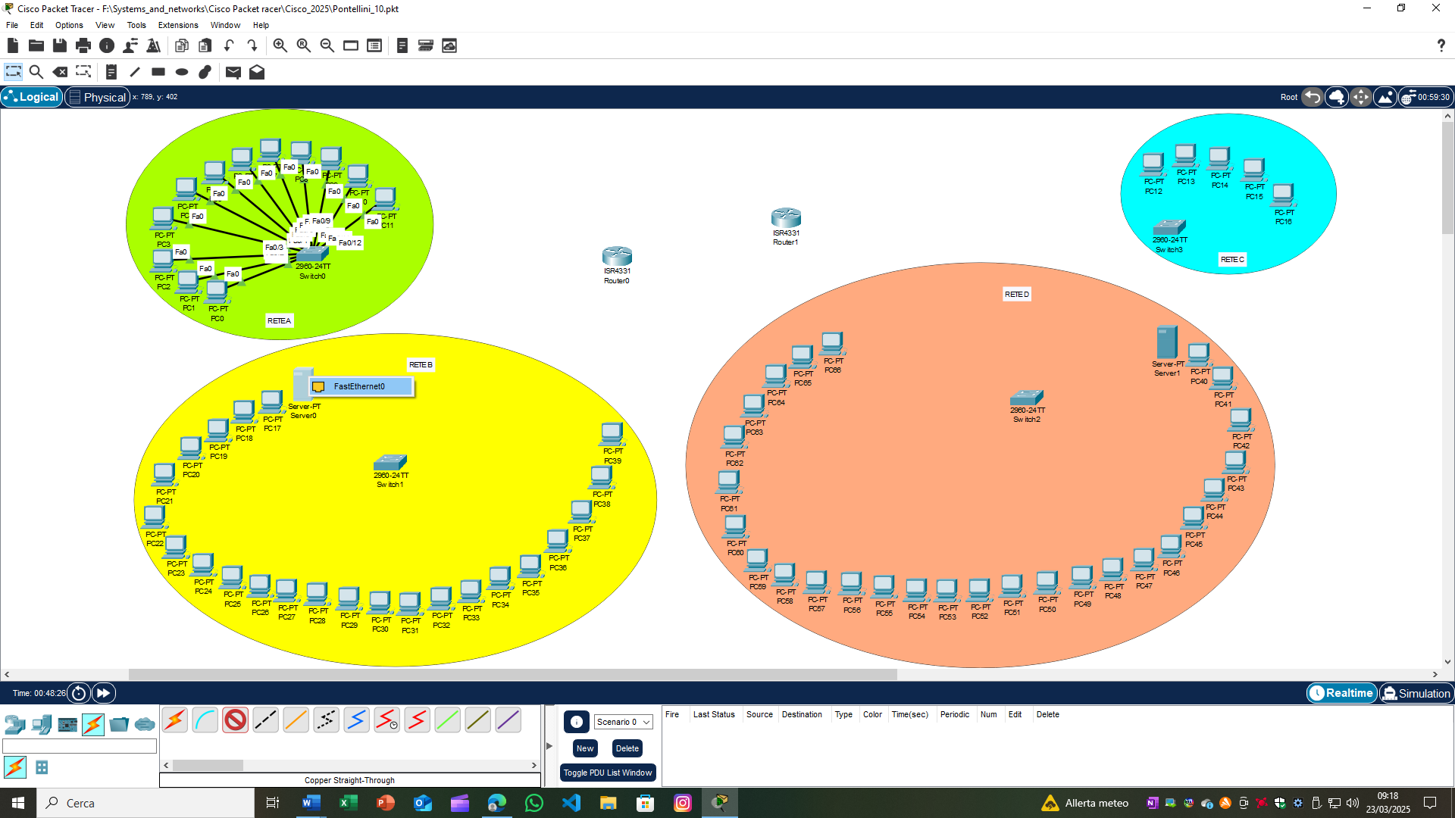

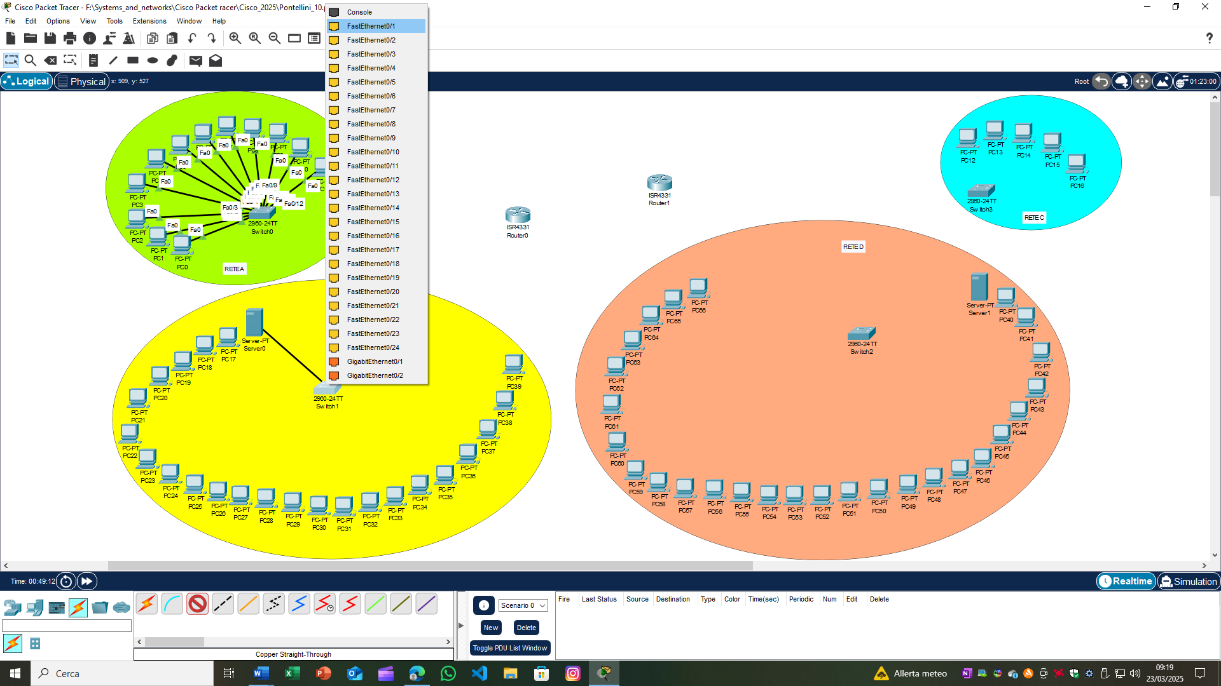

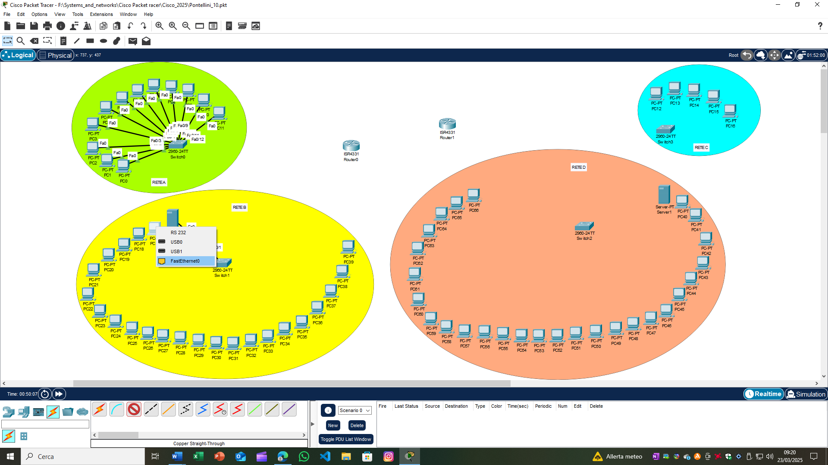

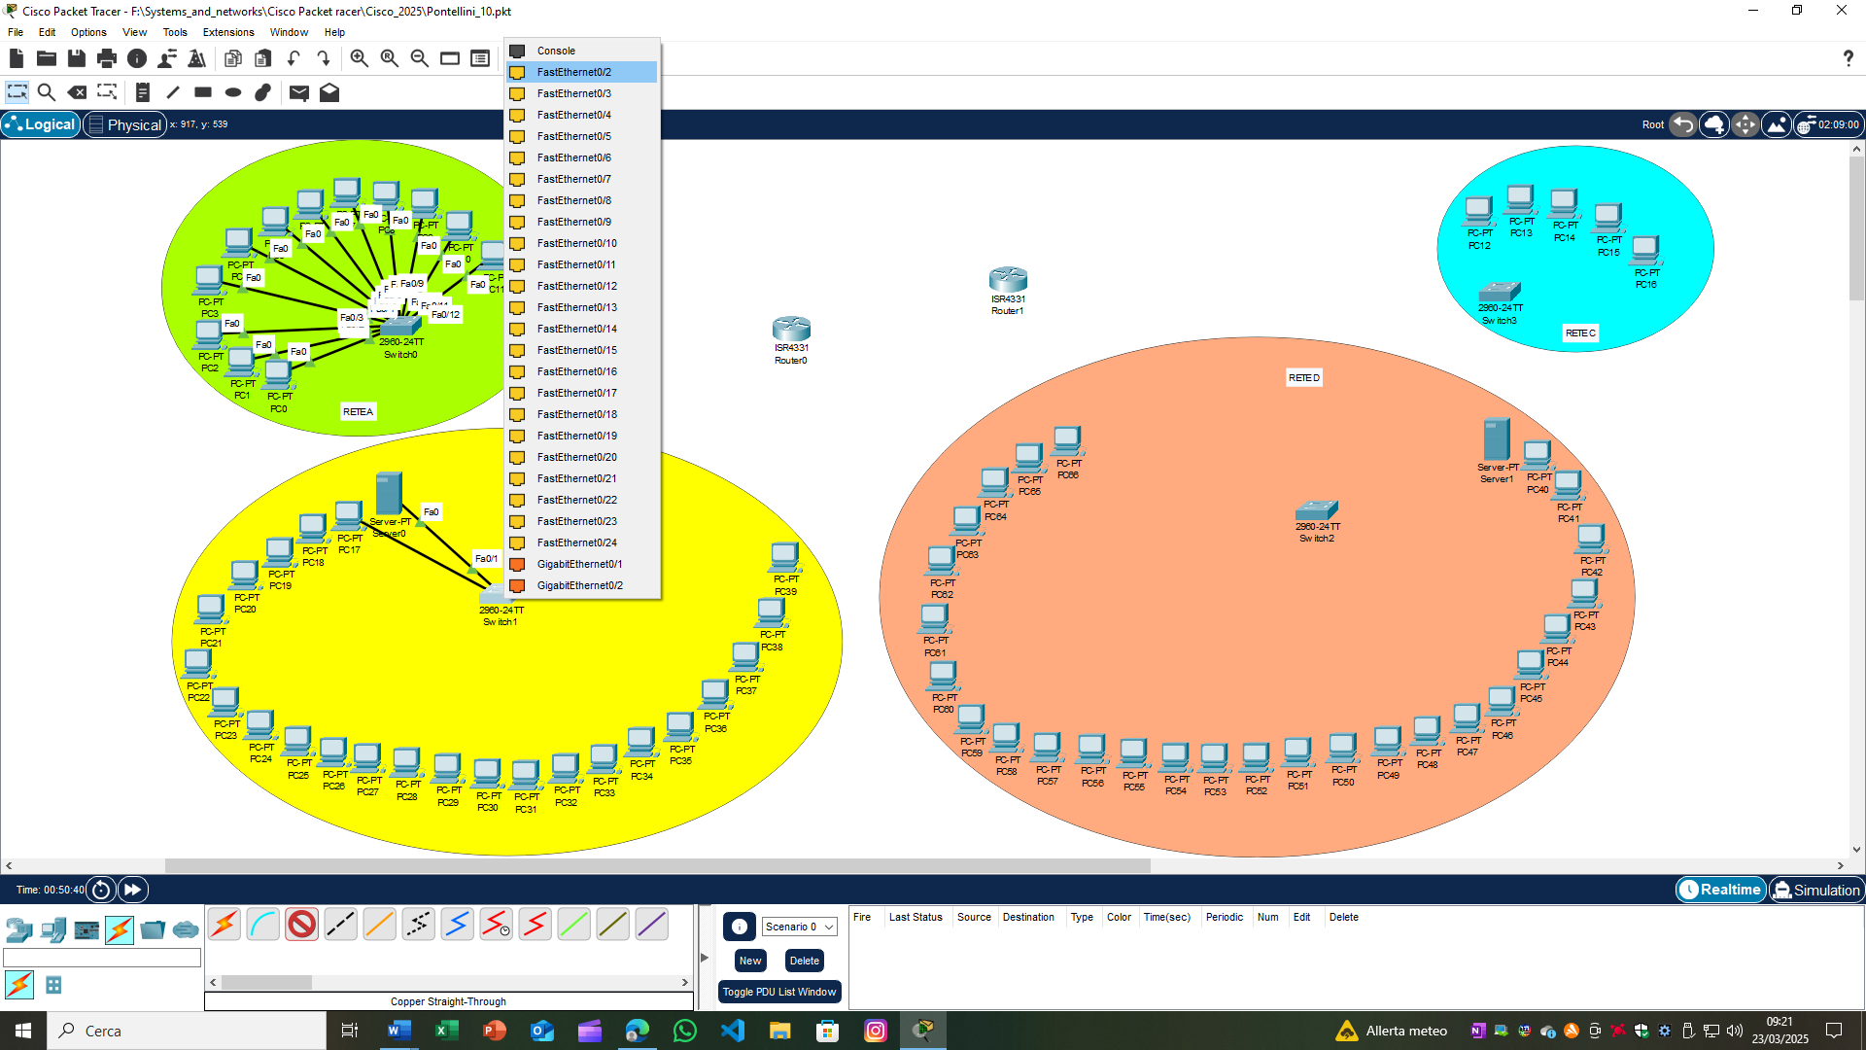

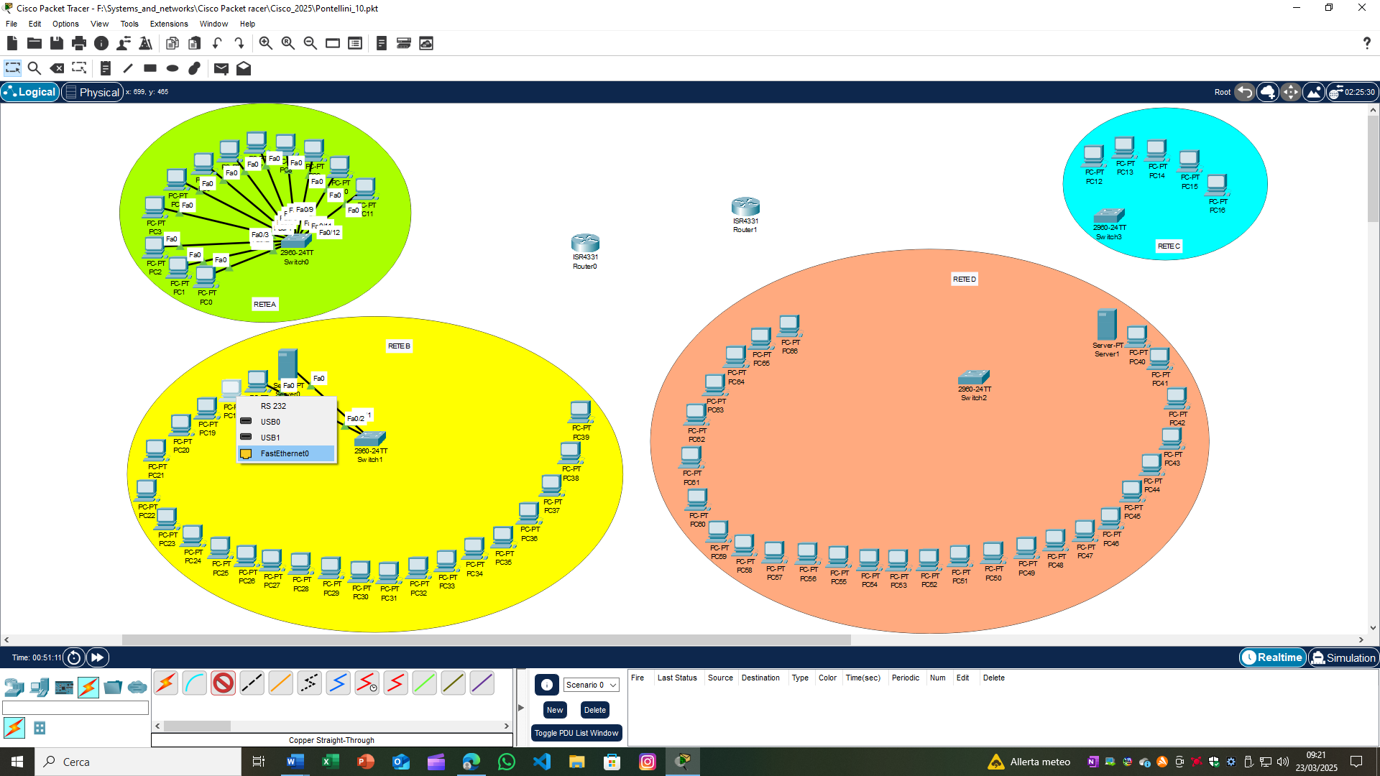

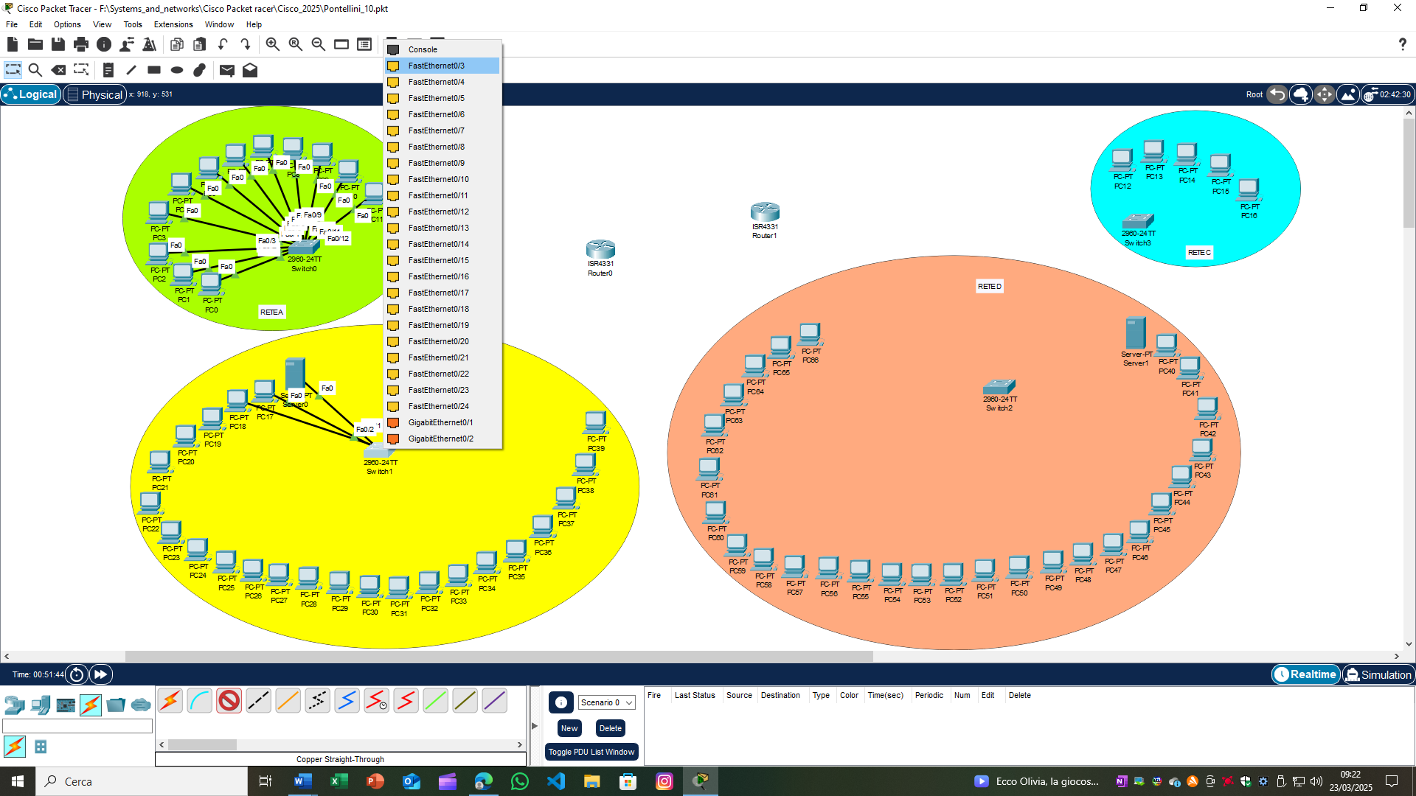

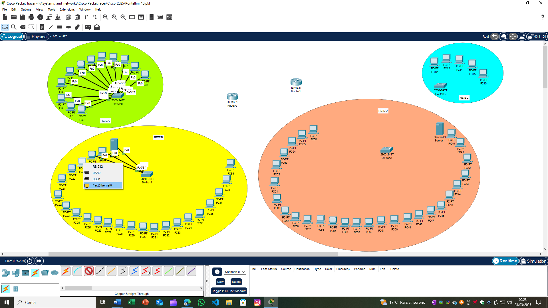

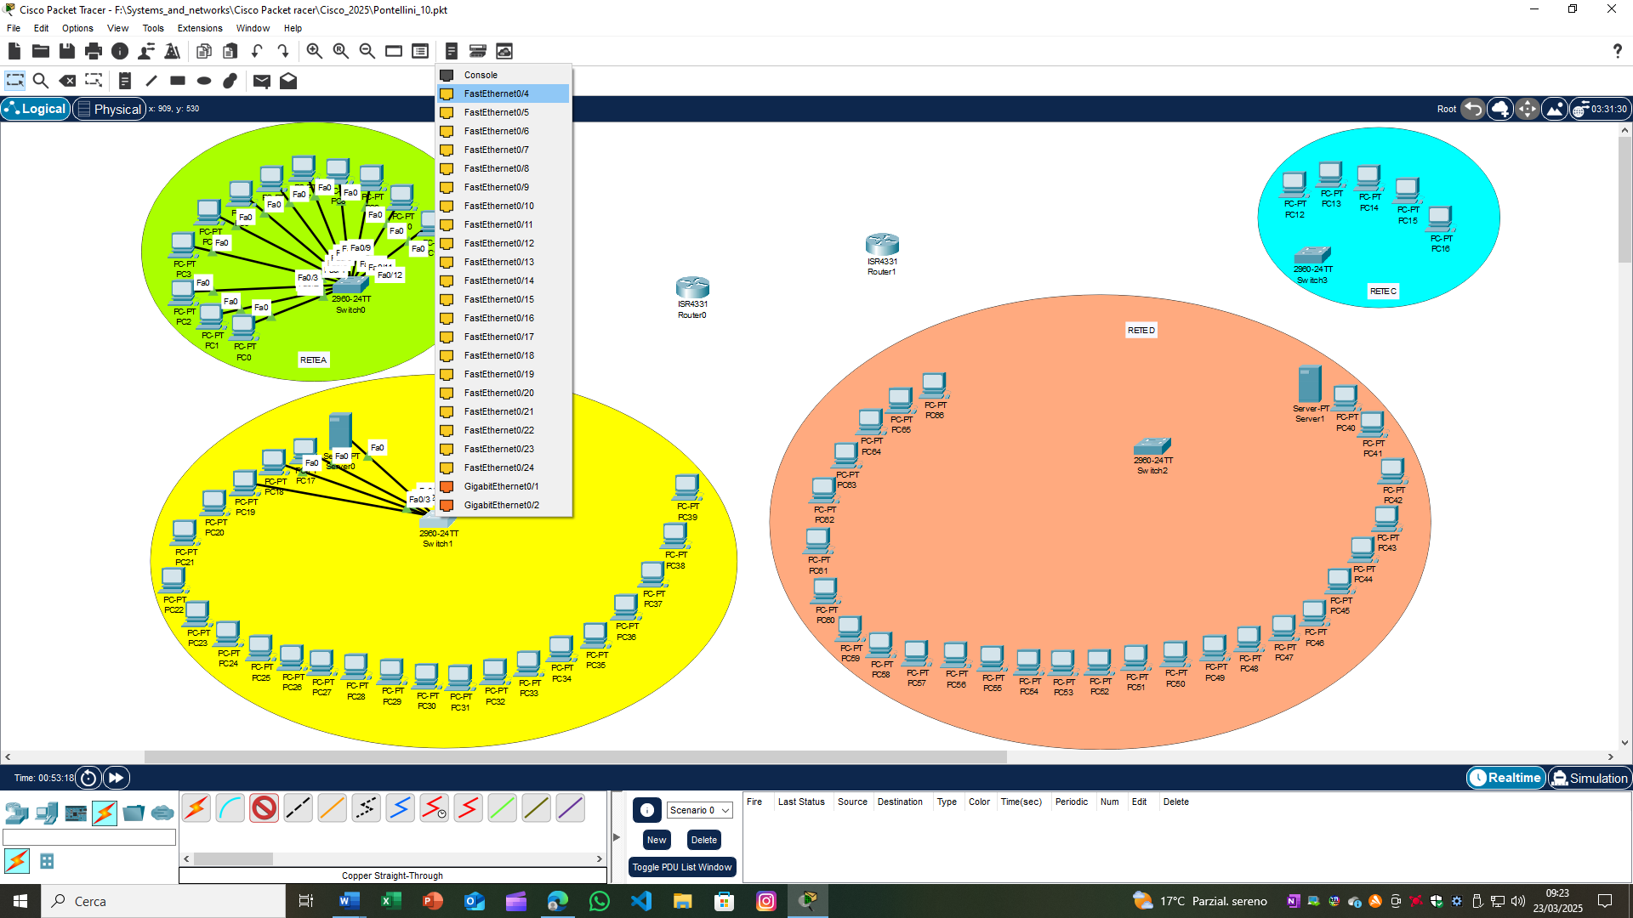

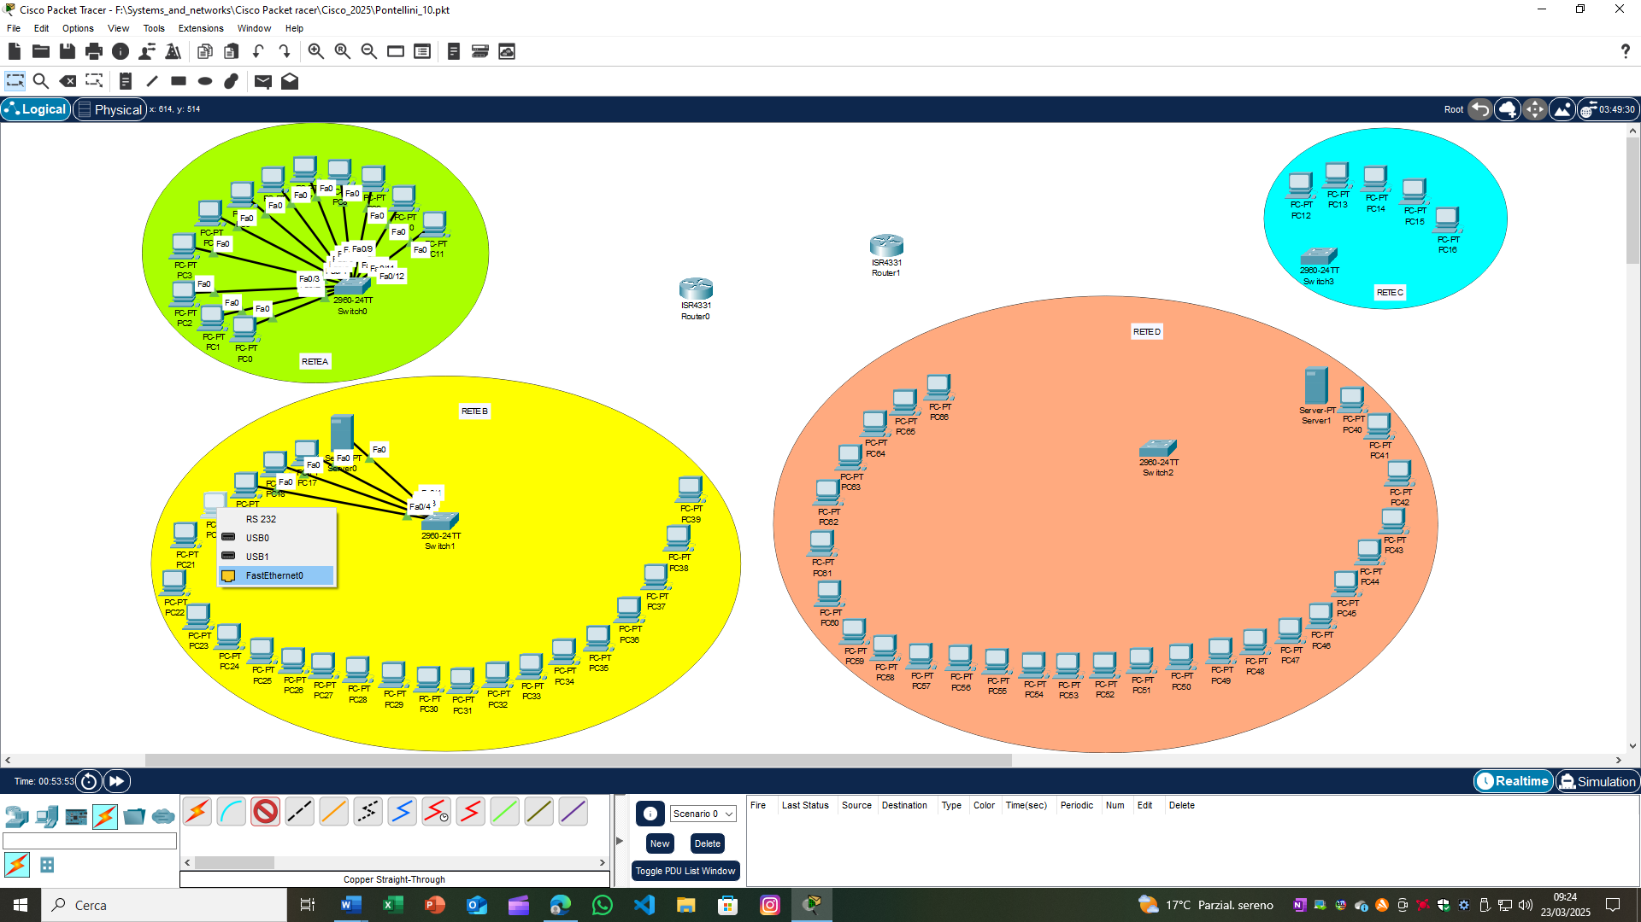

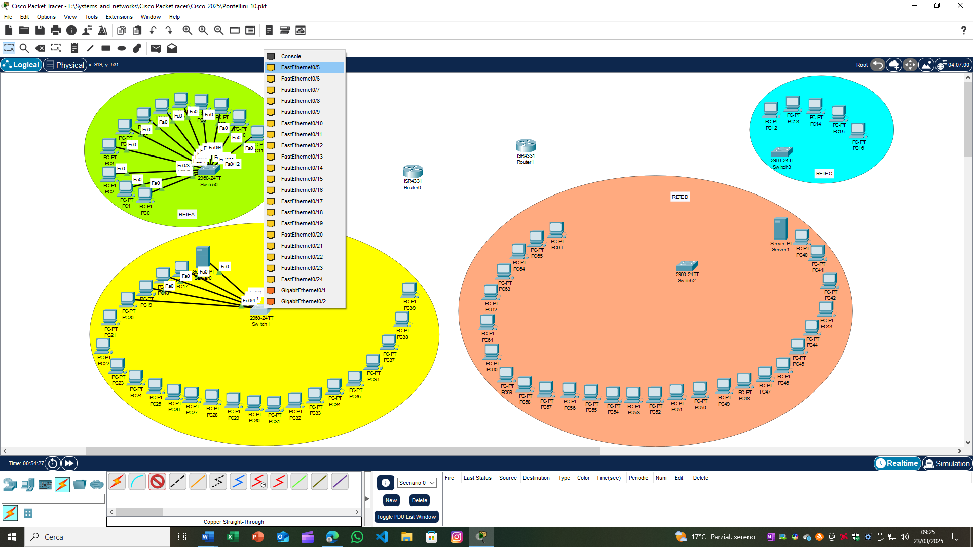

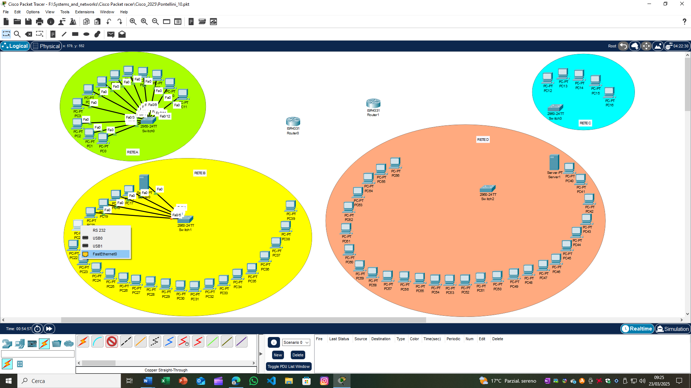

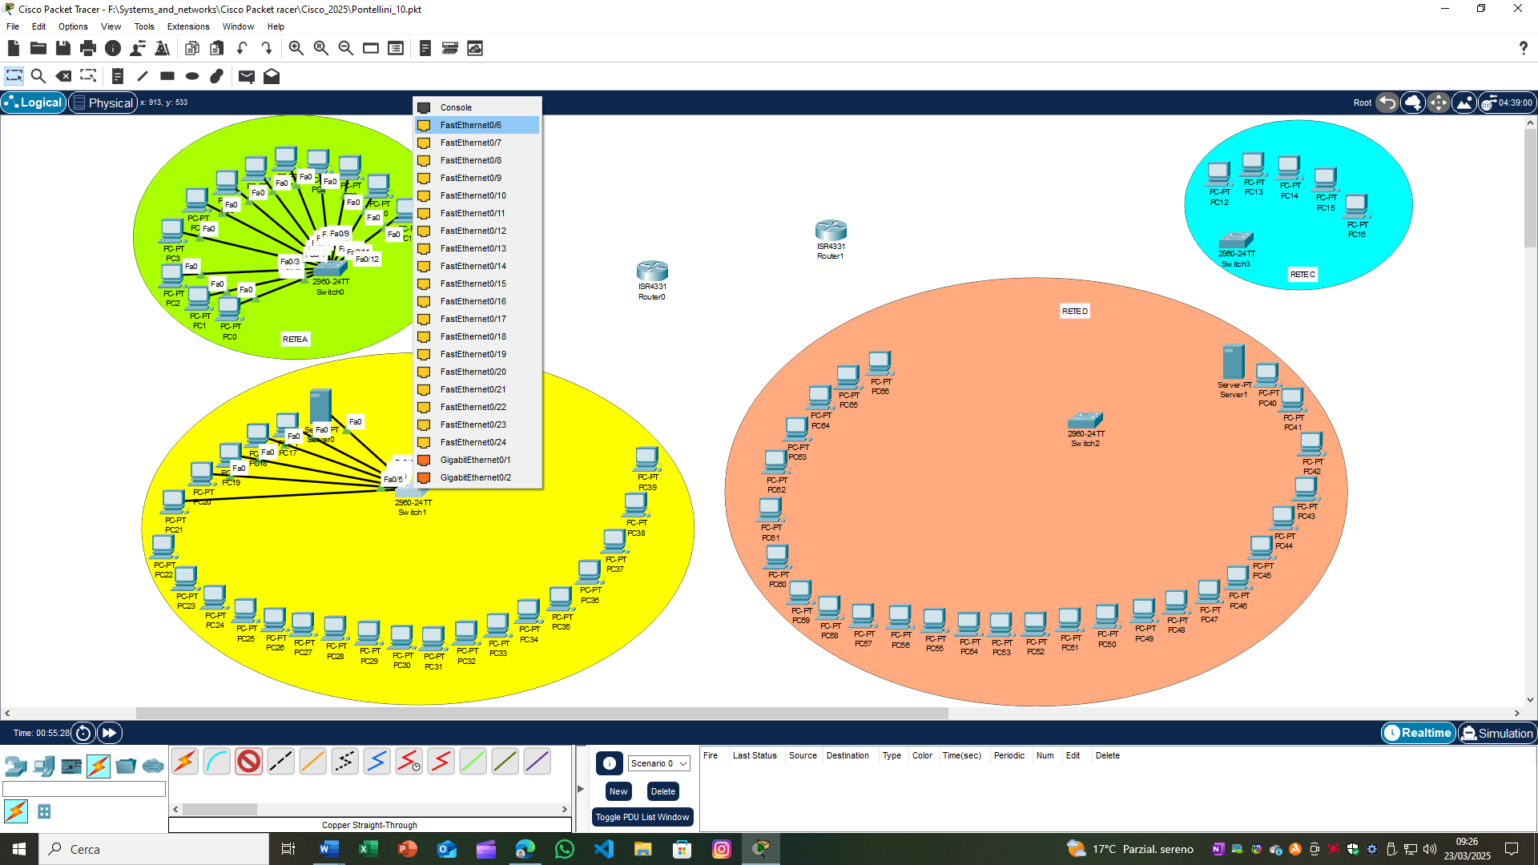

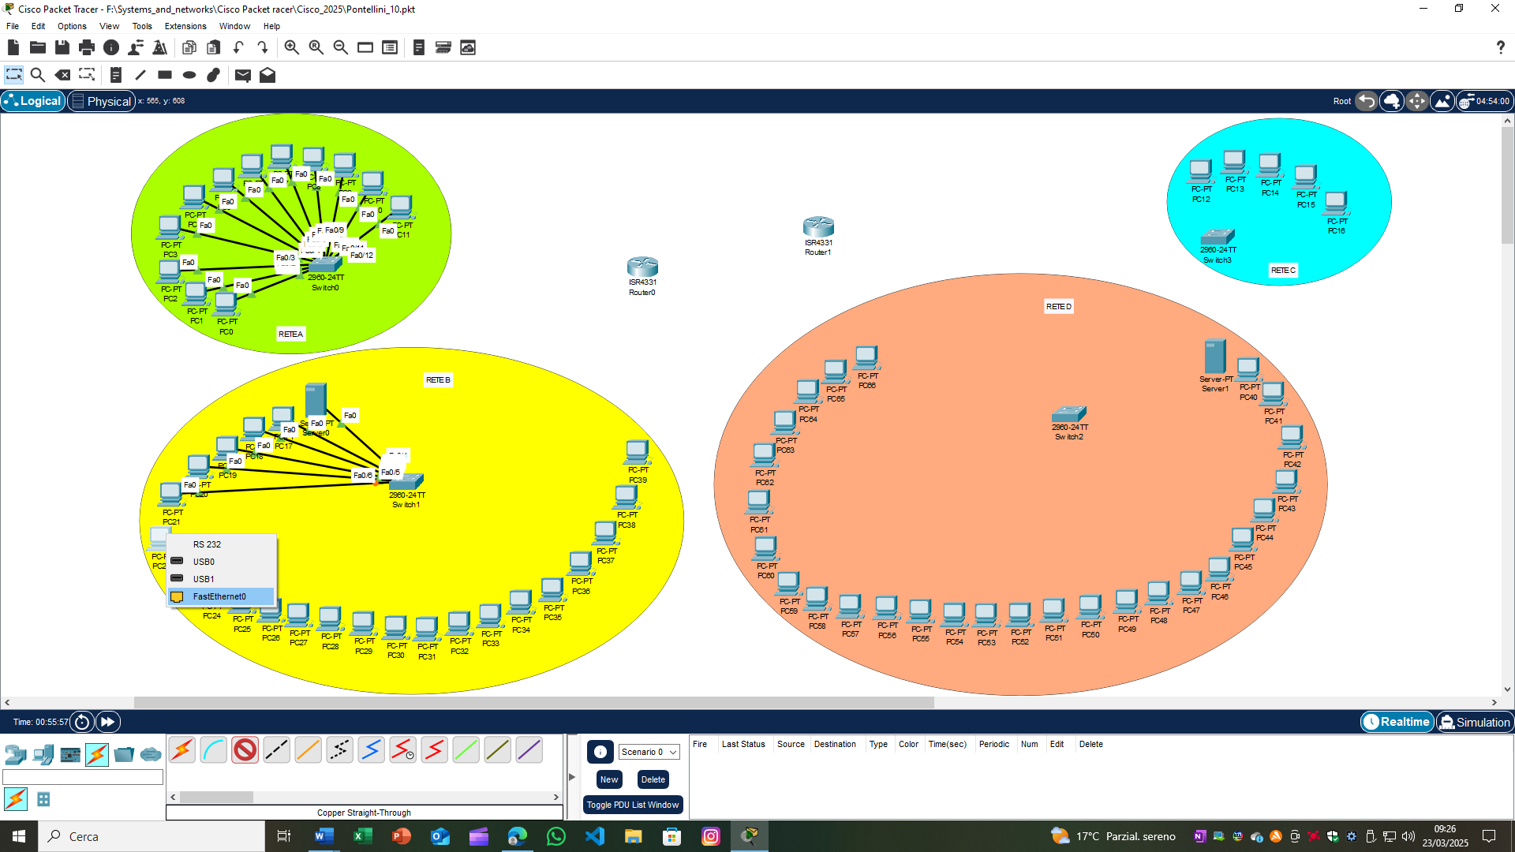

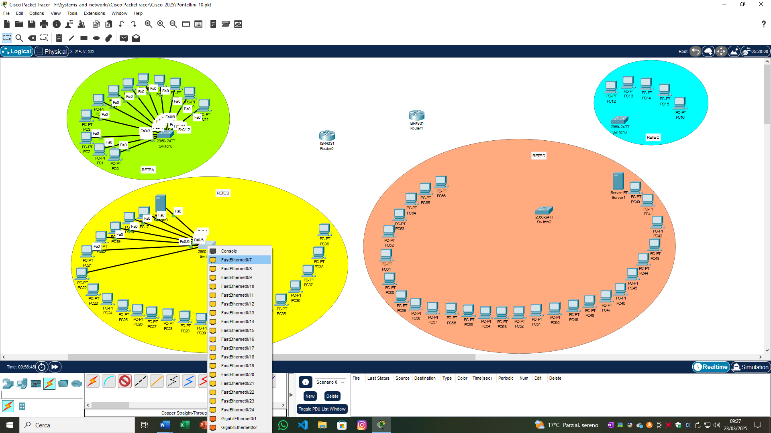

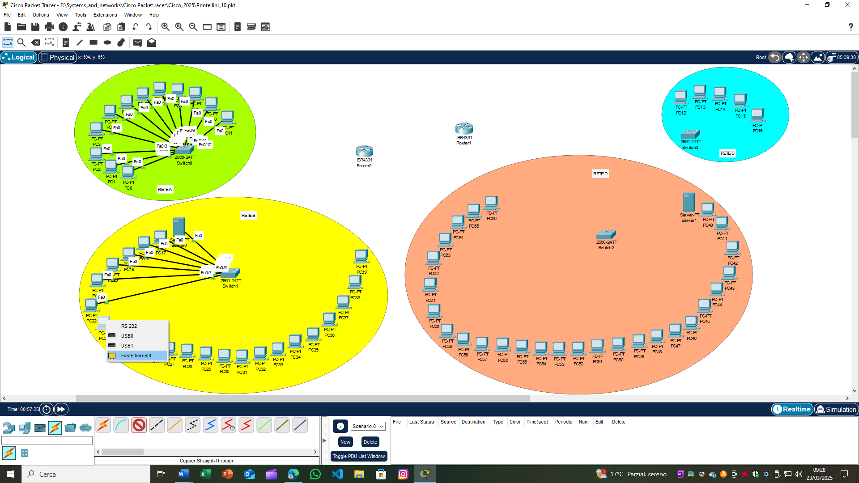

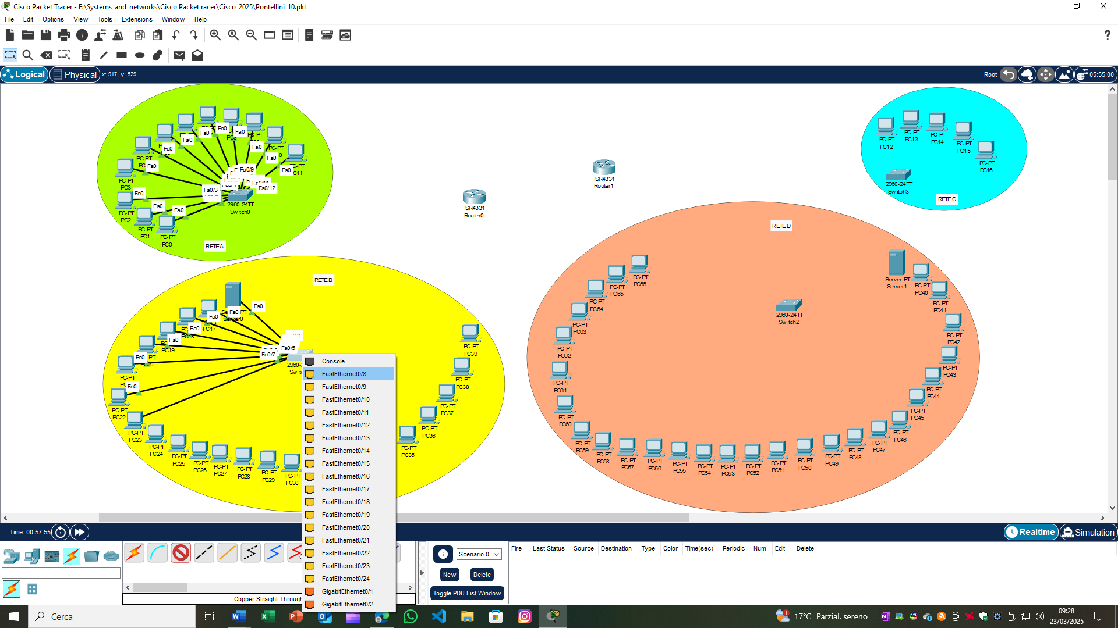

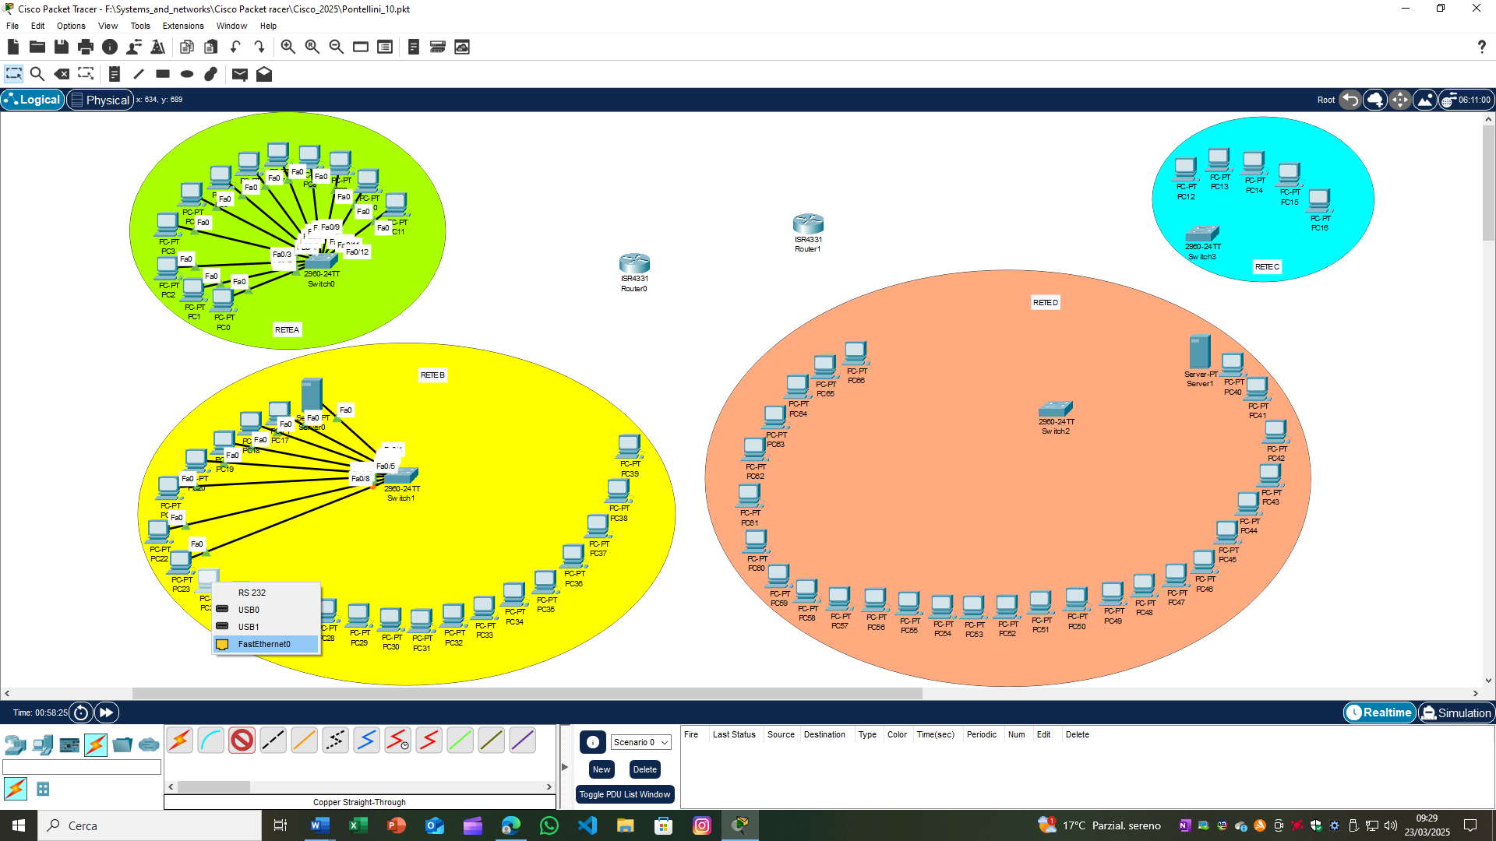

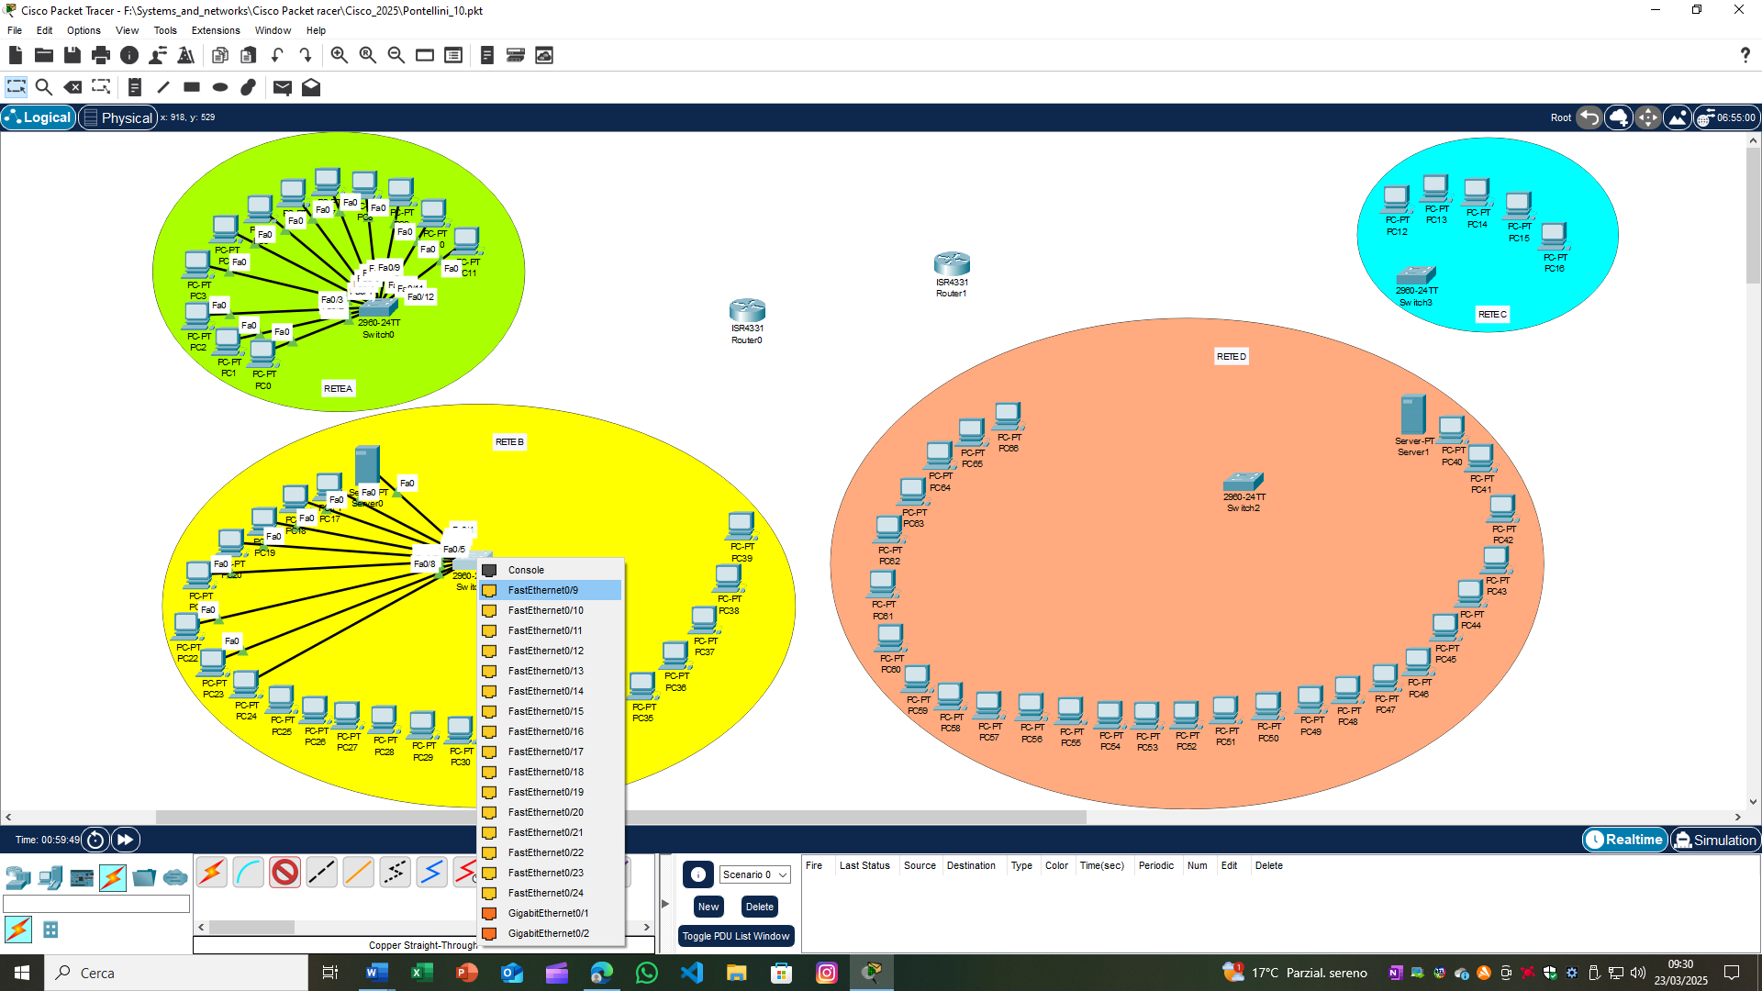

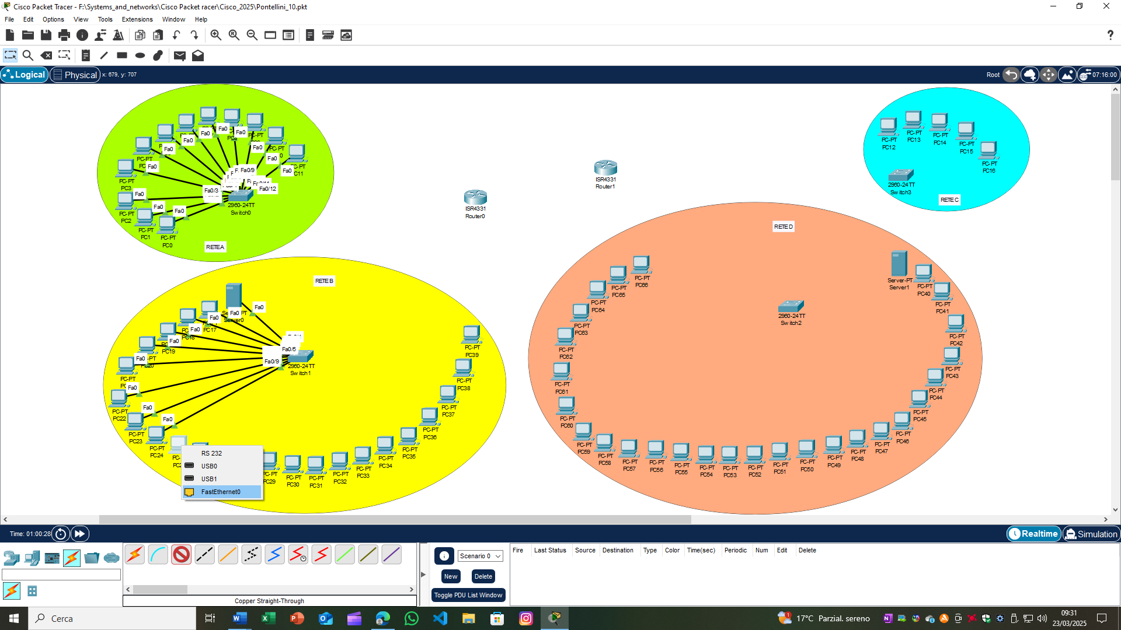

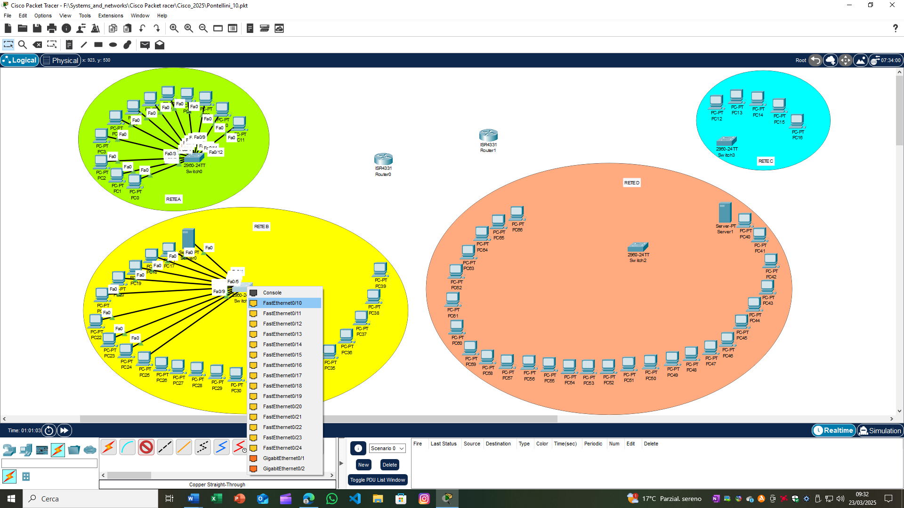

**RETE C:**

* Collegare i PC (PC-PT PC12, PC-PT PC13, PC-PT PC14, PC-PT PC15 e PC-PT PC16) allo switch 2960-24TT (Switch3) utilizzando le porte FastEthernet0/1, FastEthernet0/2, FastEthernet0/3, FastEthernet0/4 e FastEthernet0/5 dello switch e le porte FastEthernet0 dei PC con cavi copper straight-through.

**RETE D:**

* Collegare i PC (PC-PT PC40, PC-PT PC41, PC-PT PC42, PC-PT PC43, PC-PT PC44, PC-PT PC45, PC-PT PC46, PC-PT PC47, PC-PT PC48, PC-PT PC49, PC-PT PC50, PC-PT PC51, PC-PT PC52, PC-PT PC53, PC-PT PC54, PC-PT PC55, PC-PT PC56, PC-PT PC57, PC-PT PC58, PC-PT PC59, PC-PT PC60, PC-PT PC61, PC-PT PC62, PC-PT PC63, PC-PT PC64, PC-PT PC65 e PC-PT PC66) e il Server-PT (Server1) allo switch 2960-24TT (Switch0) utilizzando le porte FastEthernet0/1, FastEthernet0/2, FastEthernet0/3, FastEthernet0/4, FastEthernet0/5, FastEthernet0/6, FastEthernet0/7, FastEthernet0/8, FastEthernet0/9, FastEthernet0/10, FastEthernet0/11, FastEthernet0/12, FastEthernet0/13, FastEthernet0/14, FastEthernet0/15, FastEthernet0/16, FastEthernet0/17, FastEthernet0/18, FastEthernet0/19, FastEthernet0/20, FastEthernet0/21, FastEthernet0/22, FastEthernet0/23, FastEthernet0/24, FastEthernet0/25, FastEthernet0/26, FastEthernet0/27 e FastEthernet0/28 dello switch e le porte FastEthernet0 dei PC e del Server1 con cavi copper straight-through.